Building Access App Deployment

# Prerequisites

1. Sign up for Power Apps.
2. You must have a valid SharePoint Online license and permission to create lists.
3. You must have a public SharePoint site where you can store the data for the app.
4. Download the Assets from GitHub Repository

# Create a home for your data

Data for the app is stored in SharePoint lists, so the first step is to create a new SharePoint site.

## Create a SharePoint site.

1. Sign in to [Office online](https://www.office.com/), and then select SharePoint.
2. Select **Create site.**

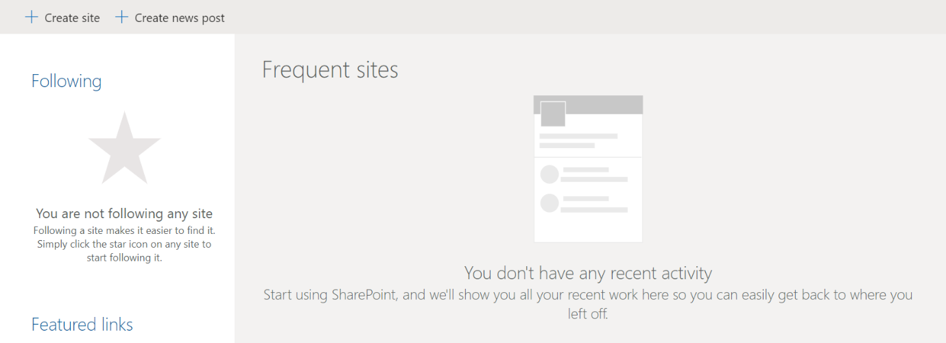

1. Select **Team site.**

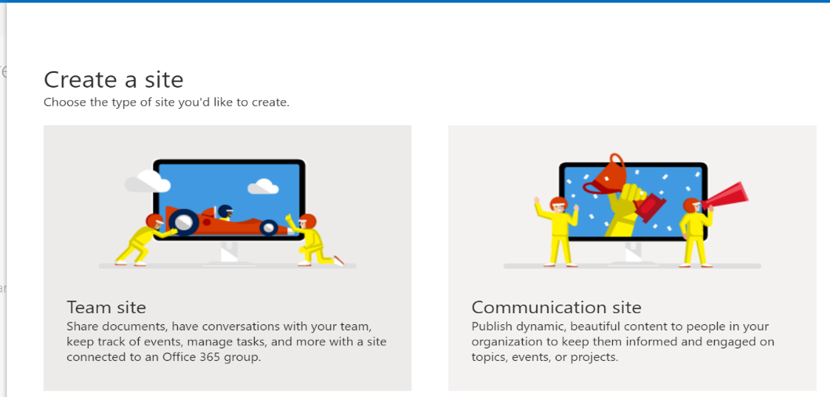

1. Enter name and description for your site.
2. Set Privacy settings to Public so that everyone in the company can get the necessary information.  
   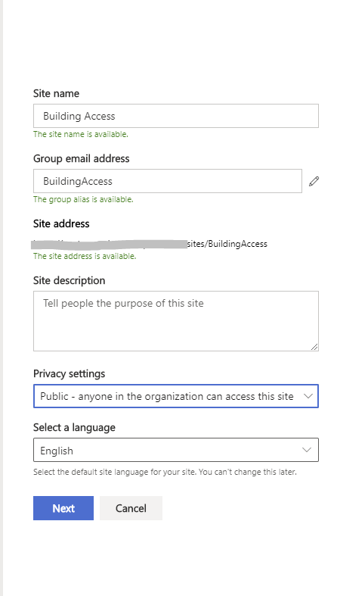
3. Select Next.
4. Add additional owners for the site (optional).
5. Select Finish.

## Create SharePoint Lists for the app

The app uses multiple lists to store its data. You can use the **DeploySPLists** power automate, available from the downloaded *assets package*, to automatically create these lists. The power automate creates the required lists, fields and sets columns as indexed.

### Import the SharePoint list deployment flow

1. Go to flow.microsoft.com.
2. Select My flows from the left navigation pane.
3. Select Import on the command bar.
4. Upload **DeploySPLists.zip** package from the GitHub Repository  
   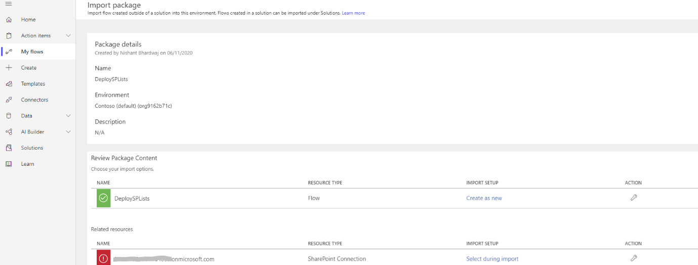
5. Add a SharePoint connection for the new flow by selecting the Select during import link and completing the form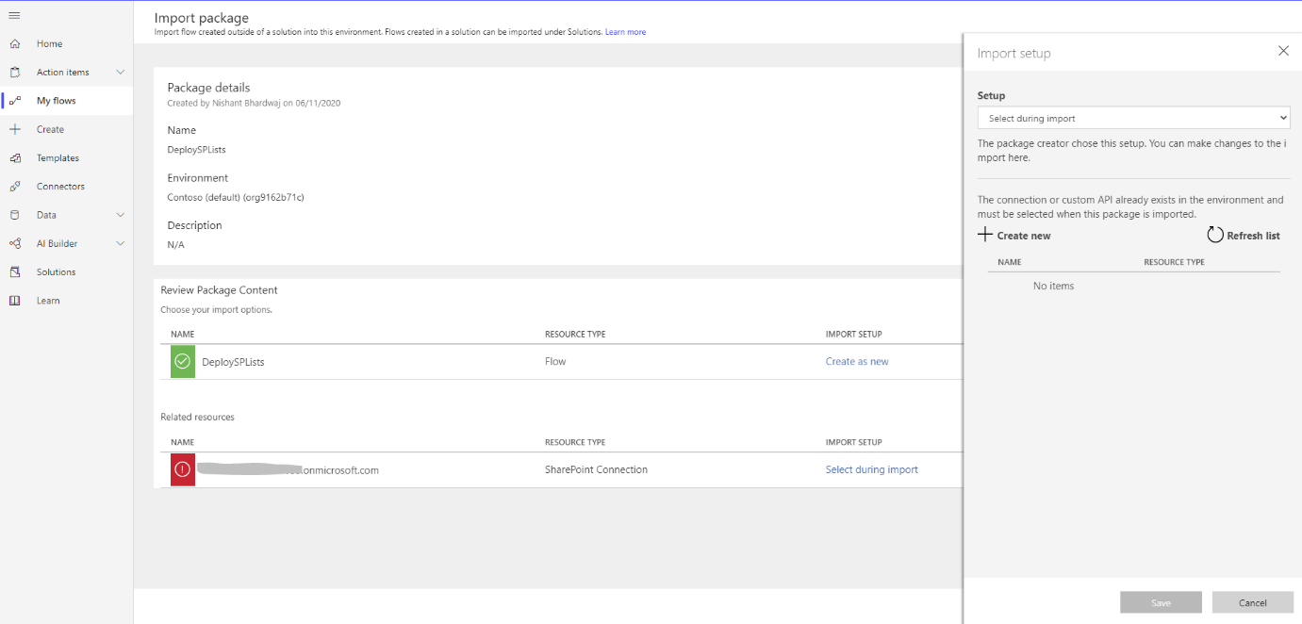
6. If you need to create a new SharePoint connection, select **Create new** in the **Import setup** pane.
7. Select **New connection** on the command bar.

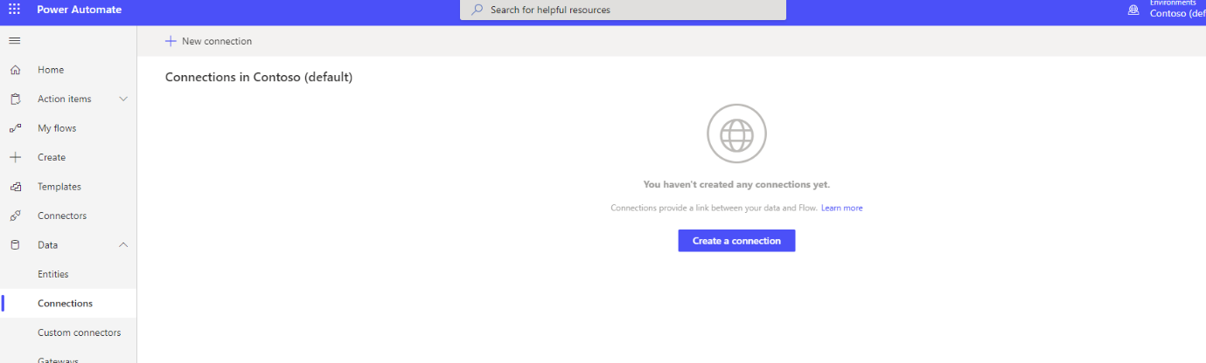

1. Search for the SharePoint connector.
2. Choose the option to “Connect directly (cloud-services).
3. Return to the tab where the flow is being imported and select the connection you just created.

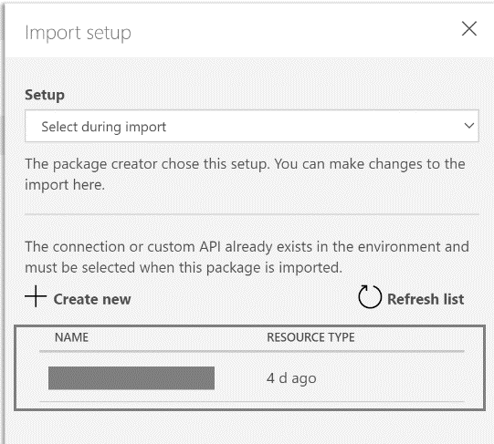

1. Select Save.
2. Select Import.

### Edit the SharePoint list deployment flow

1. After the import is done, go to My flows and refresh the list of flows.
2. Select the newly imported flow, DeploySPLists.
3. Select Edit on the command bar.
4. Open the Variable - Target Site for Lists card.
5. For Value, enter the URL of your SharePoint site (e.g. https://contoso.sharepoint.com/sites/BAR).
6. Open the Variable – App name card.
7. For Value, enter the name of your app; by default, the name is Building Access.

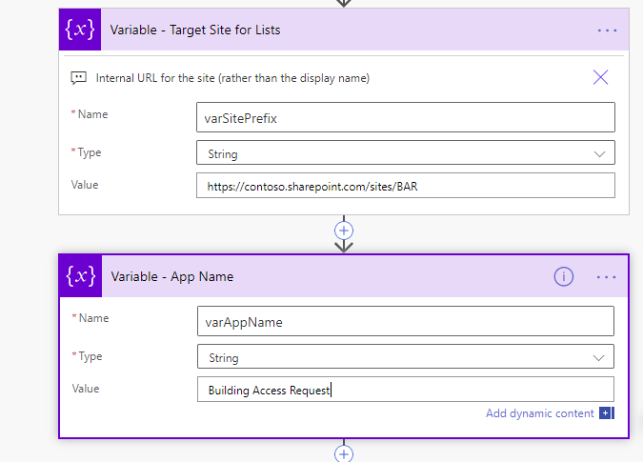

1. Select Save.

### Run the SharePoint list deployment flow

1. Click the back arrow to return to the detail screen for the Deploy_SPLists flow.
2. Select Run on the command bar.
3. Select Continue, and then select Run flow

***Note:***

*You might receive an error stating that location services are required. If this occurs, allow location services to access Power Automate and refresh the page before trying again.*

1. Refresh the flow detail screen until the run status changes from running to Succeeded.



1. The flow creates the following SharePoint lists in your SharePoint site. Return to the SharePoint site you specified above and verify that they are now created by clicking on the gear icon in the top right, then Site Contents.

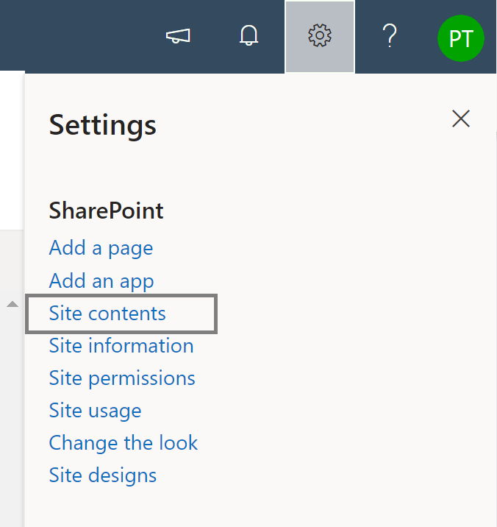

1. You should see the following Document Library and Lists created. Learn more about their purpose in the table below.

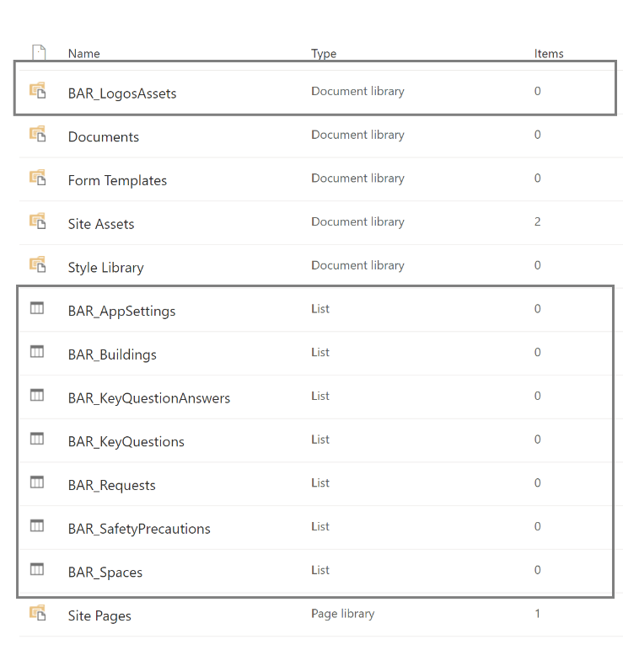

|  |  |  |
| --- | --- | --- |
| **Display Title** | **Purpose** | **Description** |
| BAR_AppSettings | Used for feature configuration by the admin of the app.  Note: This list should be read-only for all members who aren't admins. | Admin configuration list for the [App Name] app. |
| BAR_Buildings | Collection of all buildings. Includes information about total number of seats in the building, maximum allowed seats. Maximum allowed seats depend on the availability threshold %. | Building list for the [App Name] app. |
| BAR_Spaces | Collection of spaces associated with a building. A space is any bookable area within the building for example, a floor or a room. | List of bookable spaces for [App name] app. |
| BAR_SafetyPrecautions | Collection of information that a company wants to relay to employees. This list could hold safety precautions or company news. | Information list for [App Name] app. |
| BAR_KeyQuestions | Collection of screening questions that an employee must respond to before making a request to the building. This feature can be turned off from the admin app. | Key Questions for [App Name] app. |
| BAR_KeyQuestionAnswers | This list stores user responses to the key questions. | Answers for Key Questions List for [App Name] app. |
| BAR_Requests | This is the core lists which holds all access requests from users. The list holds key request information. | Request list for [App Name] app.AccessKey,Approver,BuildingID,CheckInTime,Created,DateValue,Modified,Requestor,Status fields are indexed in this list |

***Note***

* *All these list columns should be considered as dependencies. Protect the lists from accidental schema changes (for example, adding new columns is allowed, but deleting columns might break the app.)*
* *Use caution when deleting list items; deleting list items deletes historical records. You can turn the deprecation value toggle from No to Yes to drop records from contacts, news, FAQs, or links.*

### Managing SharePoint 5000 Item Limit

It is essential that certain columns within the BAR_Request list are indexed. This is to avoid any delegation issues if the SharePoint lists crosses the 5000 list items. Column indexing for Building Access App is automatically set by the DeploySPLists flow.

For more information on SharePoint field indexing refer to this [article.](https://support.microsoft.com/en-us/office/add-an-index-to-a-sharepoint-column-f3f00554-b7dc-44d1-a2ed-d477eac463b0)

## SharePoint Security

SharePoint lists should be configured using principal of least privilege. This is to ensure that the users are only given privileges that they require for seamlessly using the Apps in an intended way.

Refer to the permission matrix below to ensure users have right level of access to the SharePoint lists.

|  |  |  |  |
| --- | --- | --- | --- |
| **LISTS** | USERS | ADMIN | SECURITY |
| **BAR_AppSettings** | Read | Read,Edit | Read |
| **BAR_Buildings** | Read | Read,Edit | Read |
| **BAR_KeyQuestionAnswers** | Read,Edit | Read,Edit | Read,Edit |
| **BAR_KeyQuestions** | Read | Read, Edit | Read |
| **BAR_Requests** | Read, Edit | Read, Edit | Read,Edit |
| **BAR_SafetyPrecautions** | Read | Read,Edit | Read |
| **BAR_Spaces** | Read | Read,Edit | Read |

In the above permissions matrix:

1. Admins are users who use the Building admin app and are responsible for configuring key settings and reference data for the Building Access App.
2. Users use the Building Access App. Users make reservation requests. Users are also managers who are responsible for approving the reservation requests.
3. Security are users who use the Building Security App. They are responsible for building security and ensuring that users follow protocols by managing their entry to the building.

***Note***

* *Currently SharePoint site has been configured as Public. This means all users in your organisation are members of the site.*
* *Admins should be configured as owners of the site.*
* *As the site is public, security users are already part of the members group of the site.*

Steps below show how to set up permissions for the BAR_AppSettings list. Same steps can be followed for other lists to provide access as per the permission matrix above.

1. Navigate to the SharePoint site.
2. Click on the gear icon on top right and then click Site Contents.

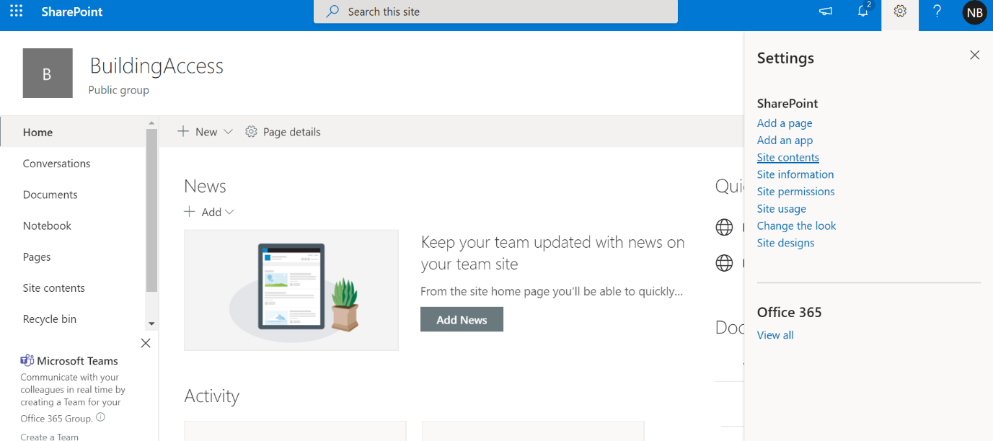

1. Click Show Actions icon and then select Settings

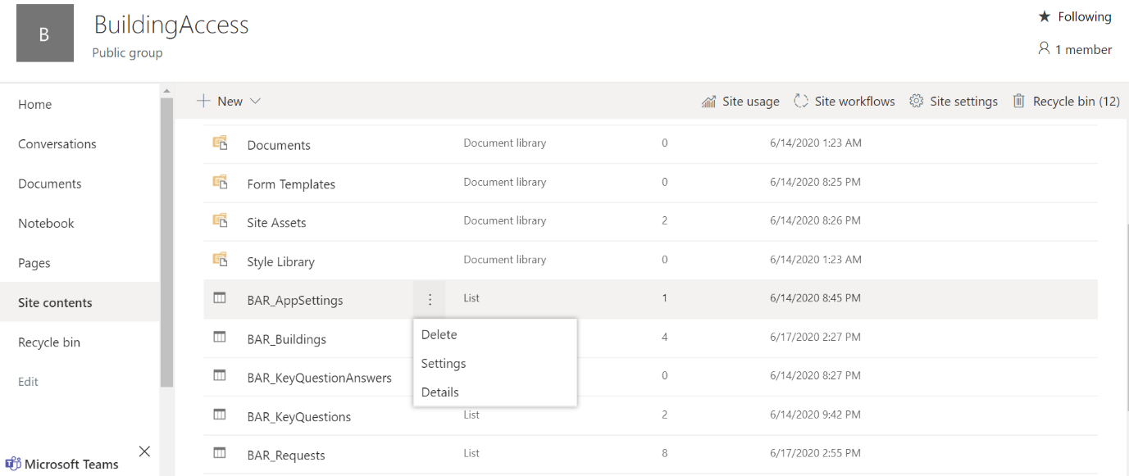

1. In the Permissions and Management section, click Permissions for this List

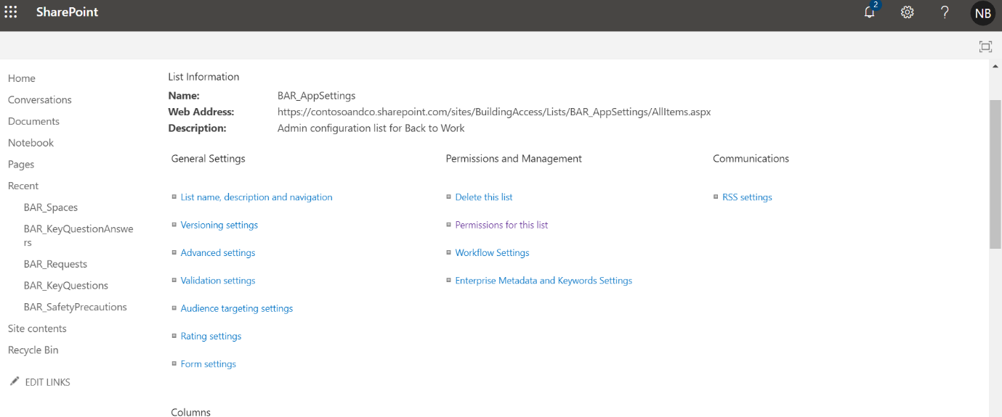

1. On the top left corner Click Stop Inheriting Permissions.

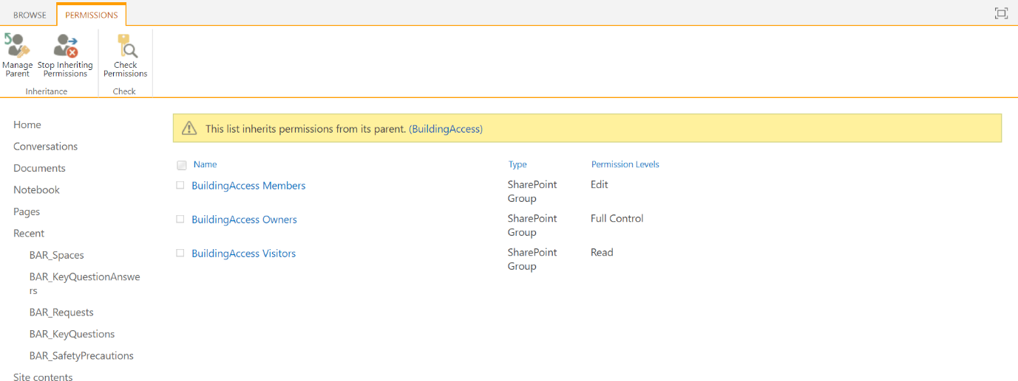

1. This creates unique permissions for the list.
2. Select the members group.
3. Select Edit User Permissions

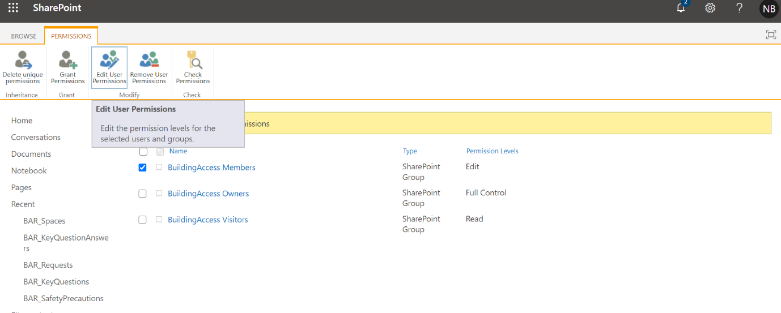

1. Uncheck Edit and check Read.

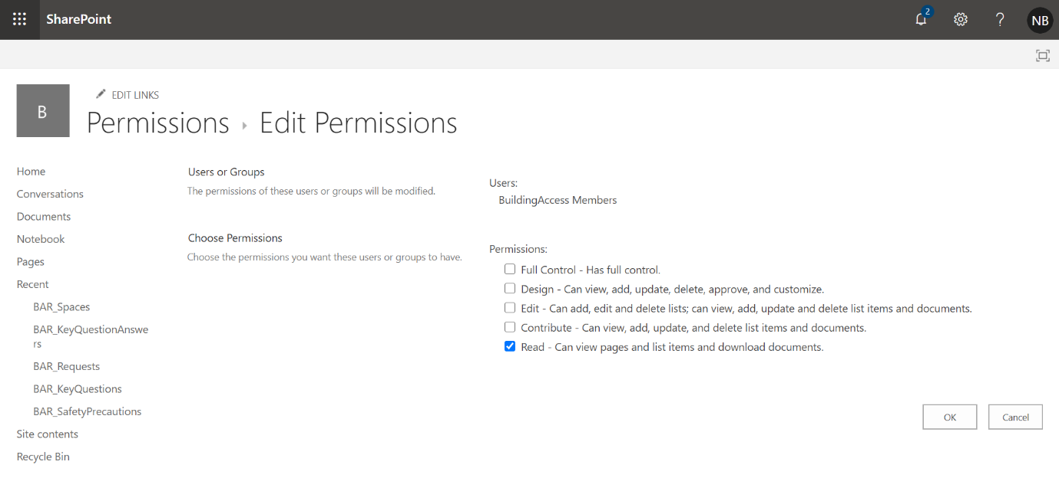

1. Click Ok.

***Note***

* *The SharePoint site can be configured as a private site.*
* *If site is configured as private, it is important that list permission matrix is followed.*

# Import and set up the Building Access app

After all SharePoint lists have been created, you can import the app and connect it to your new data sources.

## Import the app

1. Sign in to [Power Apps](https://make.powerapps.com/).
2. Select Apps from the left navigation pane.
3. Select Import on the command bar.
4. Upload the BuildingAccess.zip file from ….

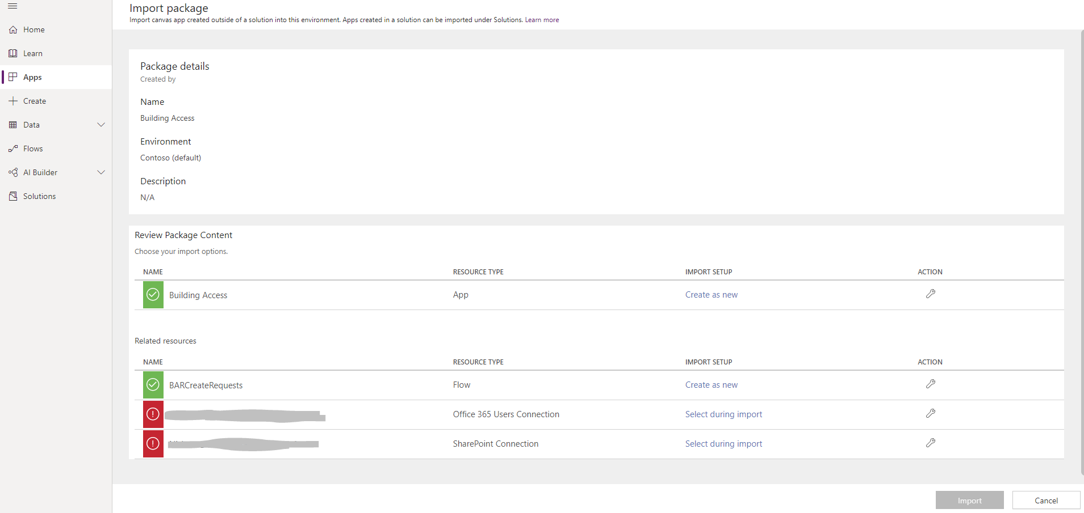

1. Complete the import setup for SharePoint Connection and Office 365 Users Connection by selecting the appropriate connections by using the Select during import hyperlink. You might have to create a [new connection](https://docs.microsoft.com/en-us/powerapps/maker/canvas-apps/add-data-connection), if it doesn't already exist.
2. Select Import.

## Update the SharePoint connections

1. Go back to the Apps list.
2. Select More commands (...) for the Building Access app.
3. Select Edit from the context menu.

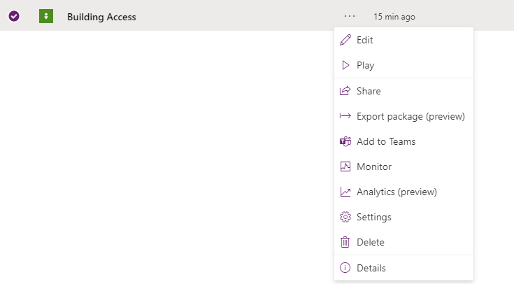

1. Sign in or create any necessary connections, and then select Allow.
2. Go to the data sources in the left pane.

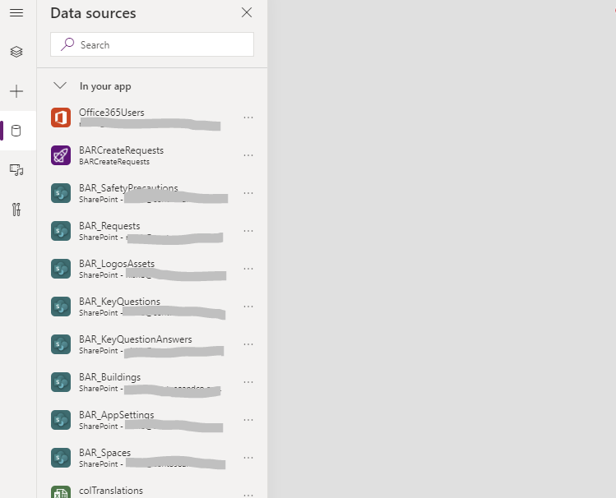

1. Click the “…” to remove existing SharePoint lists inside the app, because they don't point to your current SharePoint site.

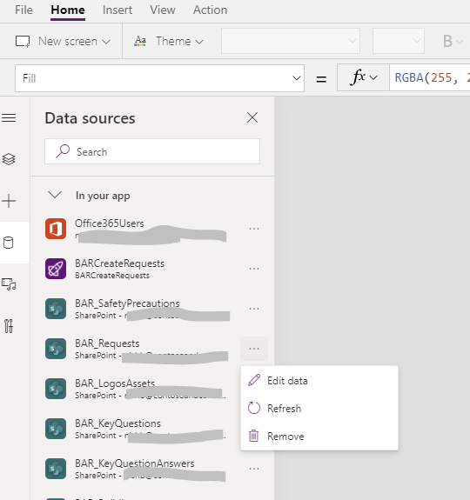

1. Add the lists from your own SharePoint site. Start by searching for SharePoint in the search bar.
2. Select SharePoint, and then choose a connection.

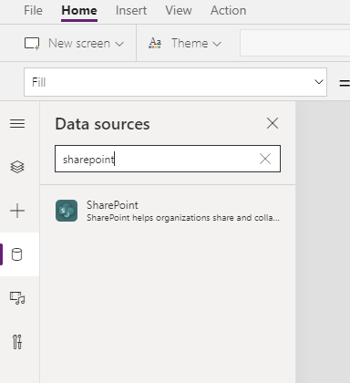

1. Copy and paste the URL to your SharePoint site in the text field, and then select Connect.

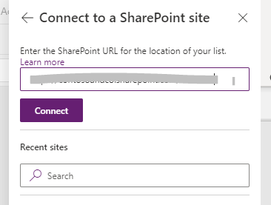

1. Select all the SharePoint lists and libraries that start with “BAR”, and then select Connect.

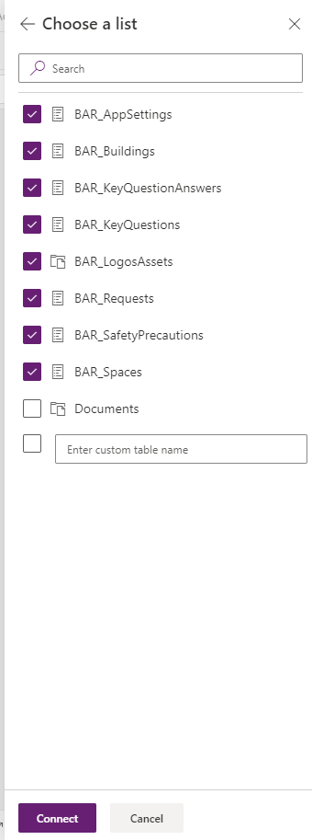

1. From the File menu, select Save, and then select Publish.

## Update the BARCreateRequests power automate.

This flow is called from within the Building Access app. This creates the building reservation request in the SharePoint list. The flow passes the context information back to the Building Access app.

1. Go to flow.microsoft.com
2. Select My Flows from the left navigation pane.
3. Select More commands(…) for BARCreateRequests, and then select Edit.
4. Open the INIVarSiteURL Lists card.

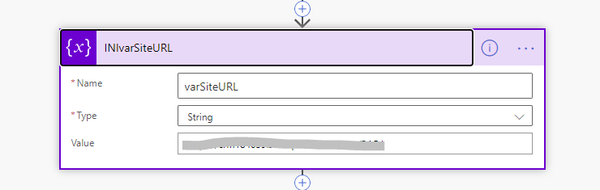

1. For Value, enter the URL of your SharePoint site.
2. For any Actions that have an orange triangle, open the action and set up a connection by clicking “Add new connection”.

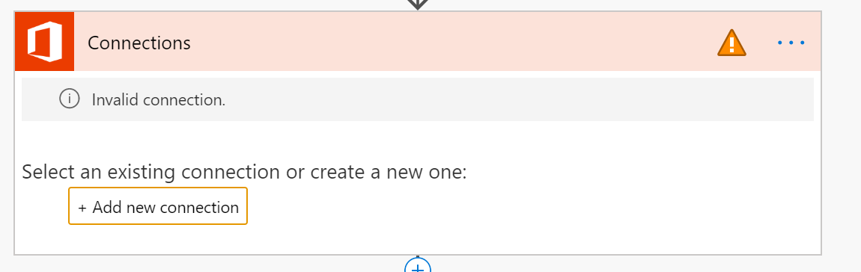

1. Select Save.

## Import and set up the BARNotifyApprover power automate

This flow sends an adaptive card to the requestor’s manager, requesting approval for the submitted request. The adaptive card is set to the manager as defined in active directory. If manager information is missing from active directory, the adaptive card is sent to the Teams’ channel as defined within the BAR_AppSettings list.

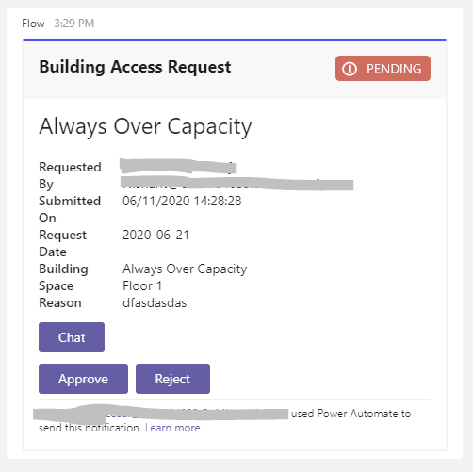

### Import Power Automate

1. Go to flow.microsoft.com.
2. Select My flows from the left navigation pane.
3. Select Import on the command bar.
4. Upload the **BARNotifyApprover.zip** package from ….

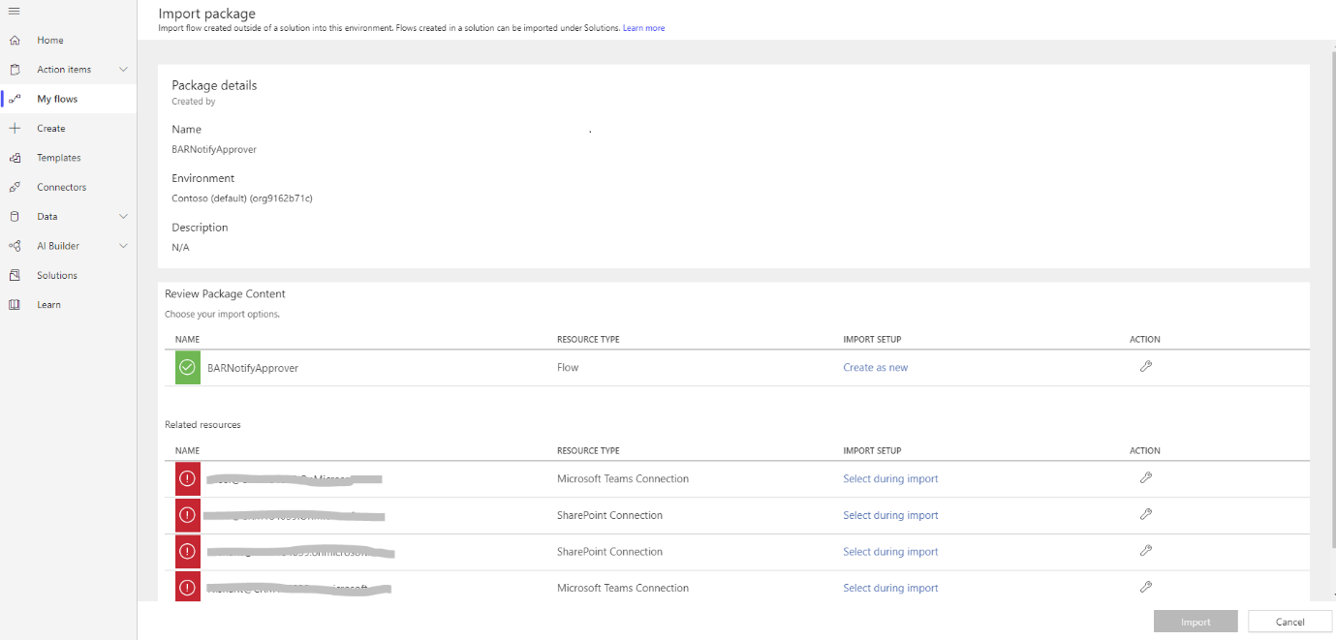

1. Add a SharePoint connection for the new flow by selecting the Select during import link and completing the form.

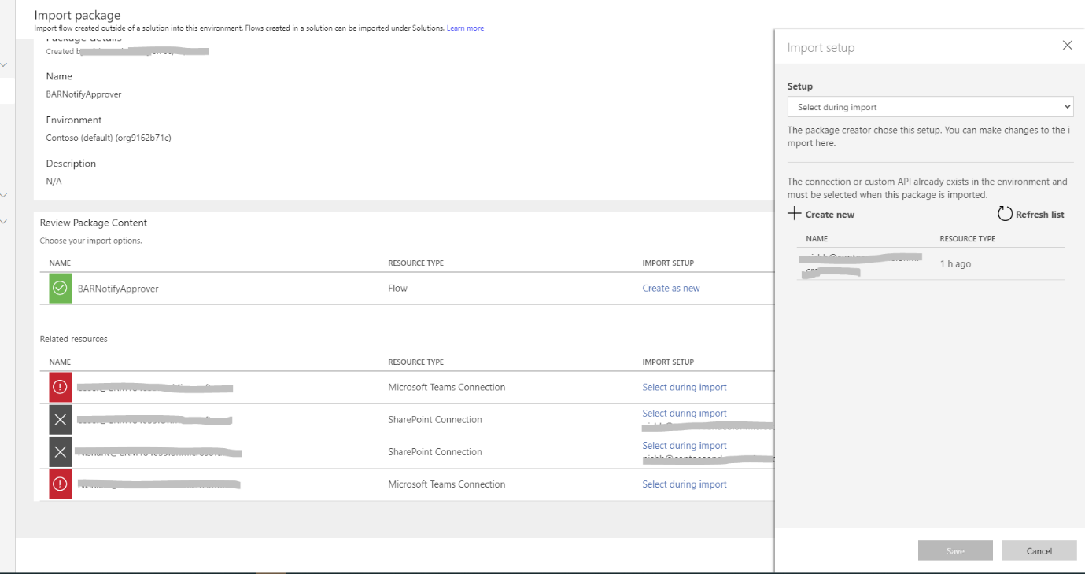

1. If you need to create a new SharePoint connection, select Create new in the Import setup pane and follow the instructions as before.
2. Add a Microsoft Teams Connection by selecting the Select during import link and completing the form.
3. If you need to create a new Microsoft Teams connection, select **Create new** in the **Import setup** pane.
4. Select **New connection** on the command bar.

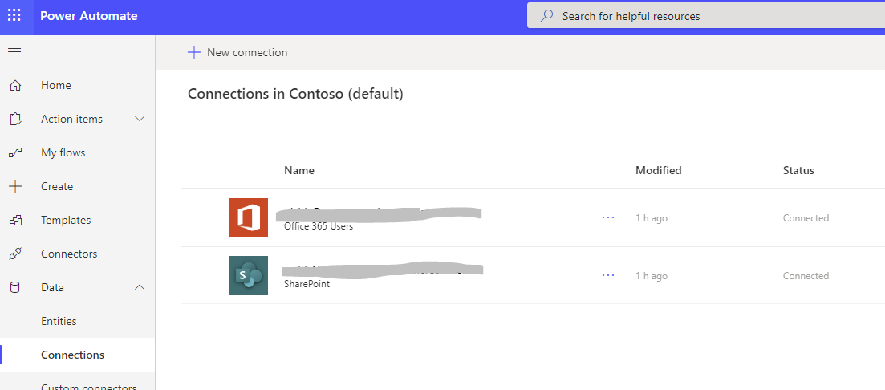

1. Search for the name of the connection, for example Teams.

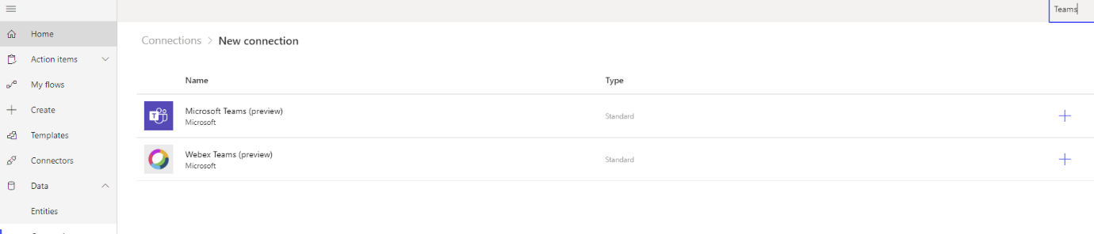

1. Select the connection you created.
2. Select Save.

## Edit the BARNotifyApprover power automate

1. After the import is done, go to My flows and refresh the list of flows.
2. Select the newly imported flow, BARNotifyApprover
3. Select Edit on the command bar.
4. Select the trigger “Request” card.
5. Change the Site Address to the URL of your SharePoint site.
6. Update the list name to BAR_Requests

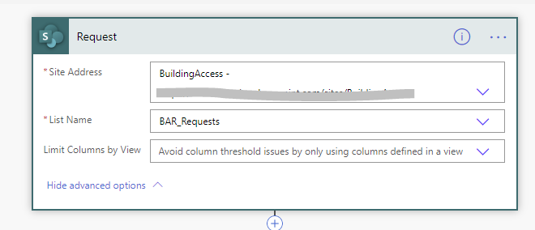

1. Open the Initialize Variable -varSiteUrl card.

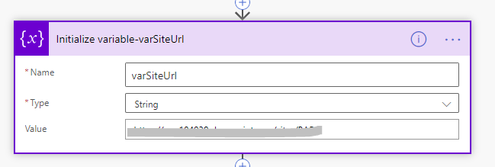

1. For Value, enter the URL of your SharePoint site.
2. Select Save.
3. If you receive a message that “Some of the connections are not authorized yet”, open the flow conditions () and switch statement () and assign a connection to the actions with an orange triangle () by clicking Add new connection.

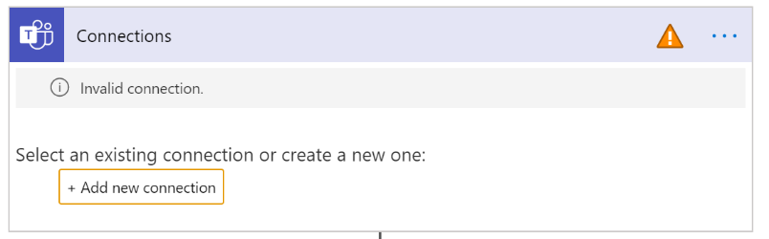

1. Once these connections are fixed, Save the flow.

# Import and set up the admin app

To manage the app you imported, repeat the same steps for the admin app.

1. Sign in to [Power Apps](https://make.powerapps.com/).
2. Select Apps from the left navigation pane.
3. Select Import on the command bar.
4. Upload the **BuildingAdmin.zip** from ….

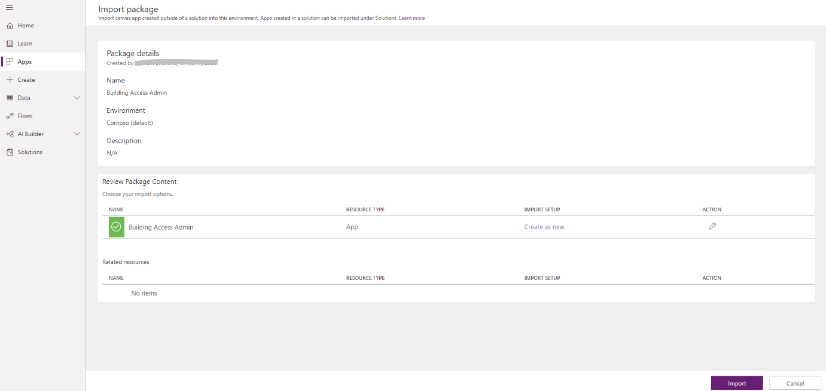

1. Select Import.

## Update connections for the admin app

1. Go back to the Apps list.
2. Select More Commands (...) for Building Access admin app.
3. Select Edit from the context menu.
4. Sign in or create any necessary connections, and then select **Allow**.
5. Go to the data sources in the left pane.



1. Remove existing SharePoint lists inside the app, because they don't point to your current SharePoint site.



1. Add the lists from your own SharePoint site. Start by searching for SharePoint in the search bar.
2. Select SharePoint, and then choose a connection.



1. Copy and paste the URL to your SharePoint site in the text field, and then select Connect.



1. Select all the SharePoint lists and libraries, and then select Connect.



1. From the File menu, select Save, and then select Publish.

# Import and set up the Security app

To manage the app you imported, repeat the same steps for the admin app.

1. Sign in to [Power Apps](https://make.powerapps.com/).
2. Select Apps from the left navigation pane.
3. Select Import on the command bar.
4. Upload the **BuildingSecurity.zip** from ….

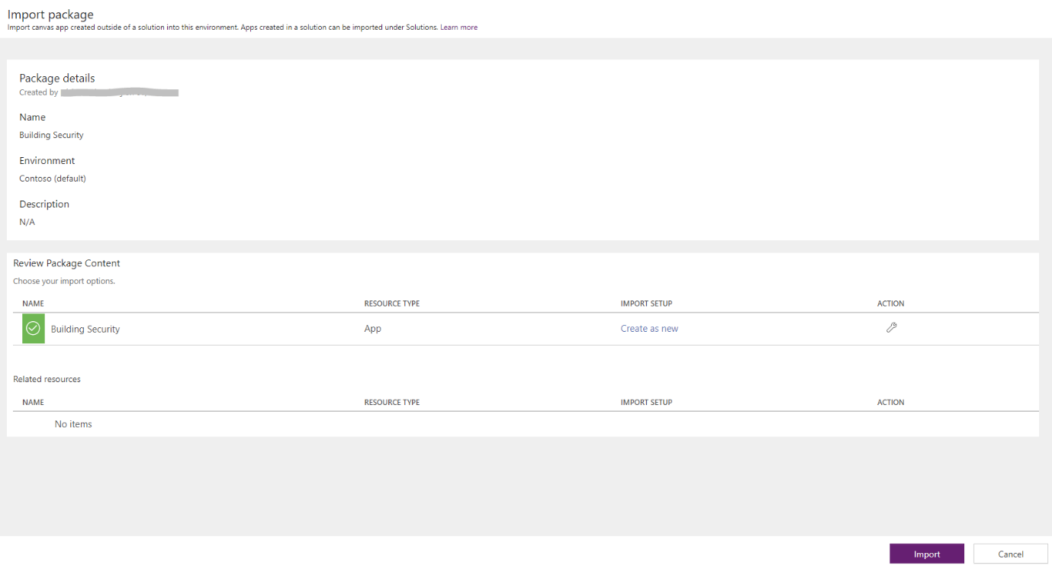

1. Select Import.

## Update connections for the security app

1. Go back to the Apps list.
2. Select More Commands (...) for Building Access Security app.
3. Select Edit from the context menu.

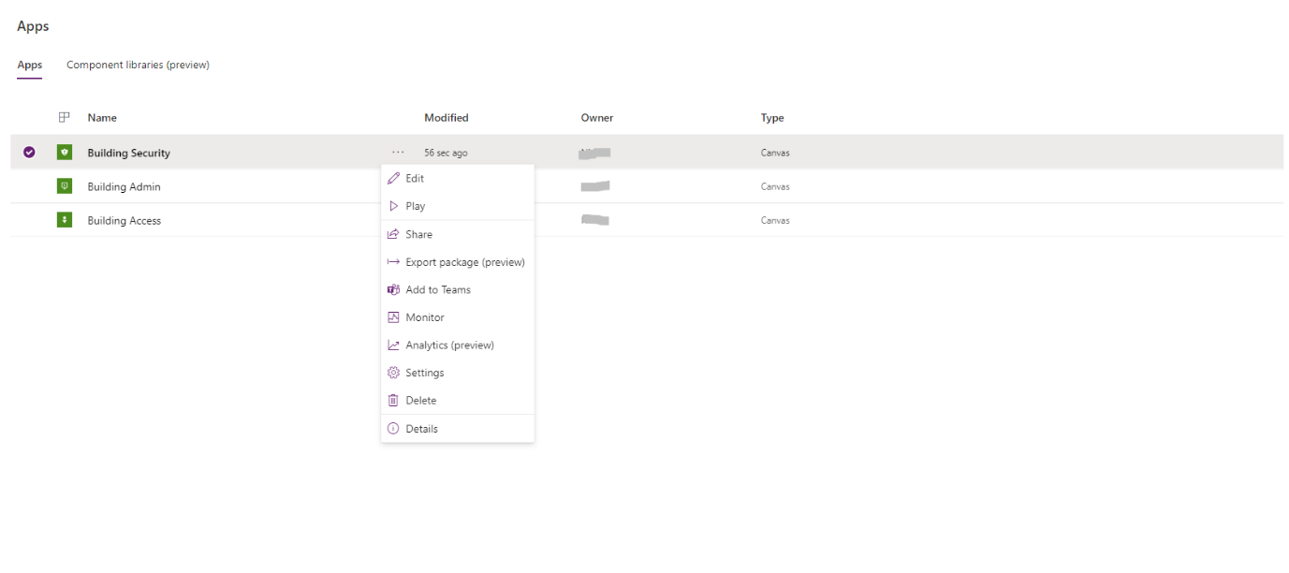

1. Sign in or create any necessary connections, and then select **Allow**.
2. Go to the data sources in the left pane.



1. Remove existing SharePoint lists inside the app, because they don't point to your current SharePoint site.



1. Add the lists from your own SharePoint site. Start by searching for SharePoint in the search bar.
2. Select SharePoint, and then choose a connection.



1. Copy and paste the URL to your SharePoint site in the text field, and then select Connect.



1. Select all the SharePoint lists and libraries, and then select Connect.



1. Select Save, and then select Publish.
2. Select Save, and then select Publish.

# Set up an Admin Team

It is important that you set up an admin team to centrally manage admin tasks like, configuring key settings and reference data, approving building access requests.

Building access requests are approved or rejected by requestor’s manager as defined in the Active directory. There might be instances where an organisation’s active directory doesn’t hold this information for user. In this case, Admin team will be responsible for approving or rejecting building access requests.

Set up an Admin team following instructions in this [article](https://support.microsoft.com/en-ie/office/create-a-team-from-scratch-174adf5f-846b-4780-b765-de1a0a737e2b?ui=en-us&rs=en-ie&ad=ie). It is recommended that you create a channel to manage building access requests. To create a channel with your newly created admin team, follow instruction in this [article](https://support.microsoft.com/en-gb/office/create-a-channel-in-teams-fda0b75e-5b90-4fb8-8857-7e102b014525?ui=en-us&rs=en-gb&ad=gb).

***Note***

* *Ensure that right users are added to the admin team.*
* *Generally, users using the Building Admin App and owners of the SharePoint site should be part of this team.*

# Create initial content for the app

At this point, you've successfully imported both the Building Access App, Building Admin app and Building Security App. You can now start creating the initial content. To start, open the Building Admin app.

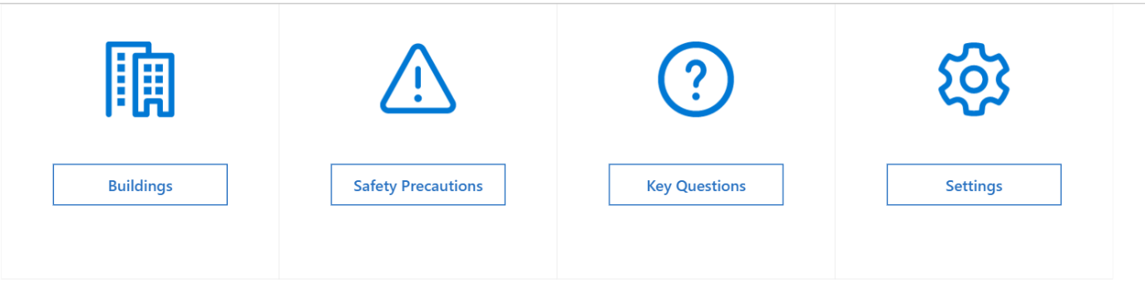

You can use the admin app to customise all the key information required in the Building Access app and to configure key settings for the app and accompanying flows.

## Set up key parameters under Settings

To initialize your app, you need to provide all the required fields by navigating to Settings.

Complete all the fields as shown in the following table, and then select Save.

|  |  |  |  |
| --- | --- | --- | --- |
| **Field name** | **Logical name in SharePoint** | **Purpose** | **Example** |
| Limit requests to X Days in future | BookingAdvance | This setting defines number of days from today in future the request to access the building can be made. | 14 |
| Admin Team ID | AdminTeamID | This is the team ID where the approval adaptive card is sent if the requestor does not have a manager assigned in Active Directory | 9cd94000-09ce-472d-976f-0a080f3a071c |
| Admin Team Channel ID | AdminTeamChannelID | This is the channel within the Admin team where the approval adaptive card is sent if the requestor does not have a manager assigned in Active Directory | 19%3a175691a3520d4e43a86  81457b687823a%40thread.tacv2 |
| Show inline approval buttons on approvals | EnableInlineApprovals | This setting enables managers to approve individual requests from the Building Access app | Yes/No |
| Enable Safety Precautions Feature | SafetyPrecautions | This setting enables/disables safety precaution feature on the Building Access App | Yes/No |
| Require Key Question completion before creating reservations | KeyQuestions | This setting makes it mandatory for requestors to answer Key eligibility questions before requesting access to a building | Yes/No |
| Key Questions failure message | KeyQuestionsFailMessage | This is the message that appears if a requestor has answered “Yes” to any of the Key Eligibility Questions | Sorry at this time you do not qualify. |

**NOTE: Retrieve Team’s ID**

1. Open teams.
2. Click on (…) next to your admin team name.
3. Click Get link to the team.

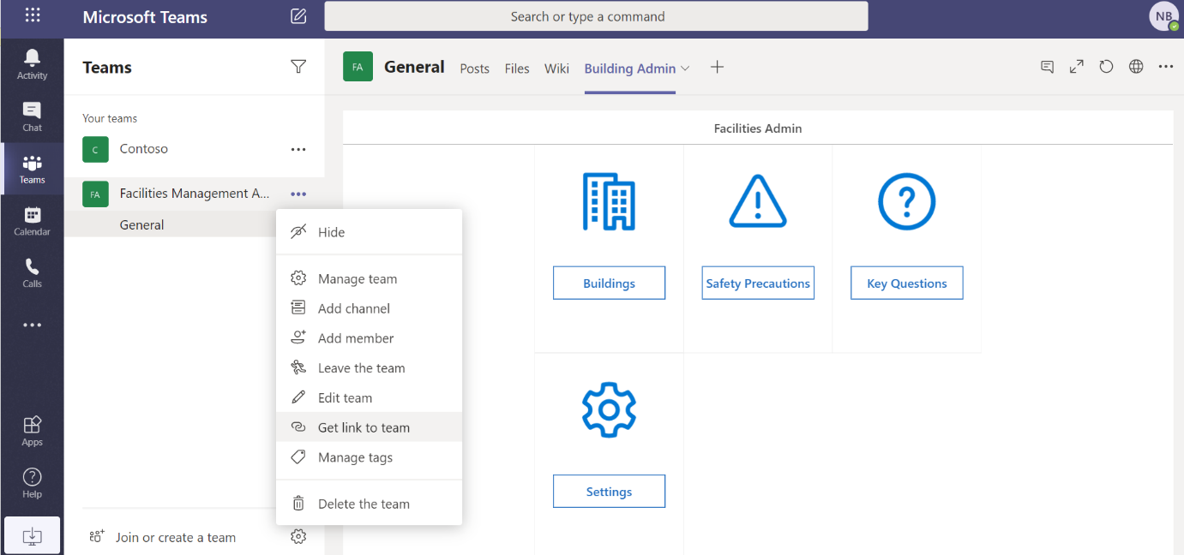

1. Copy the team’s link and paste in a text editor like notepad.

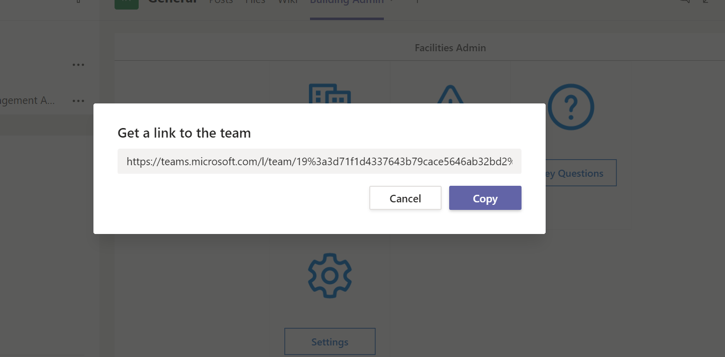

1. The link is in the format

**https://teams.microsoft.com/_?tenantId=<Tenant ID>&groupId=<Team ID>**

1. The value of the groupid parameter is the id of your team.

**NOTE: Retrieve Team’s Channel ID**

1. Navigate to the admin team’s channel.
2. Click (…) next to the channel name.
3. Click get link to the channel.

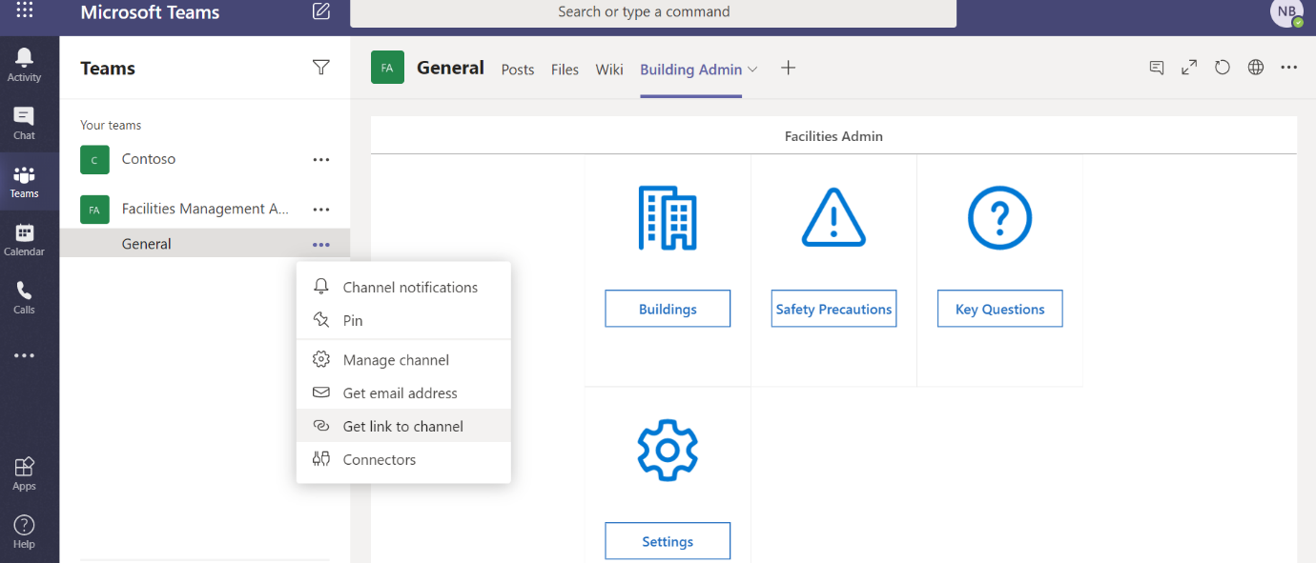

1. Copy the channel link in a text editor like notepad.
2. Extract the id between channel/ and /general. This is your channel id.

# Sharing PowerApps

You need to share your PowerApps with relevant users in order to make the apps available to use. For guidance on sharing a canvas app, refer to this [article.](https://docs.microsoft.com/en-us/powerapps/maker/canvas-apps/share-app)

It is important that you share the apps with right users. As an example,

1. Building Access app can be shared with all users in your organisation who are required to request access to a building.
2. Building Admin can be shared with Facilities Admin users, who are responsible for managing key information like Buildings.
3. Building Security can be shared with security personnel, who are responsible for managing entry to a building.

# Deploying Building Access App to Teams

Deploying the Building Access App to teams is an easy way to promote adoption, centralize discussions, and amplify information across the organization. Teams Admins, as well as end-users, can add this app to Teams, albeit with slightly different steps. Once you have downloaded the app following the written or video instructions above, the steps below walk through the process to deploy it to Teams.

## Download the Building Access App from Power Apps Homepage

1. Navigate to <https://make.powerapps.com>
2. The Building Access app should appear under “Your Apps”.
3. Click the “…” to the right of the app name, then select the “Add to Teams” option.

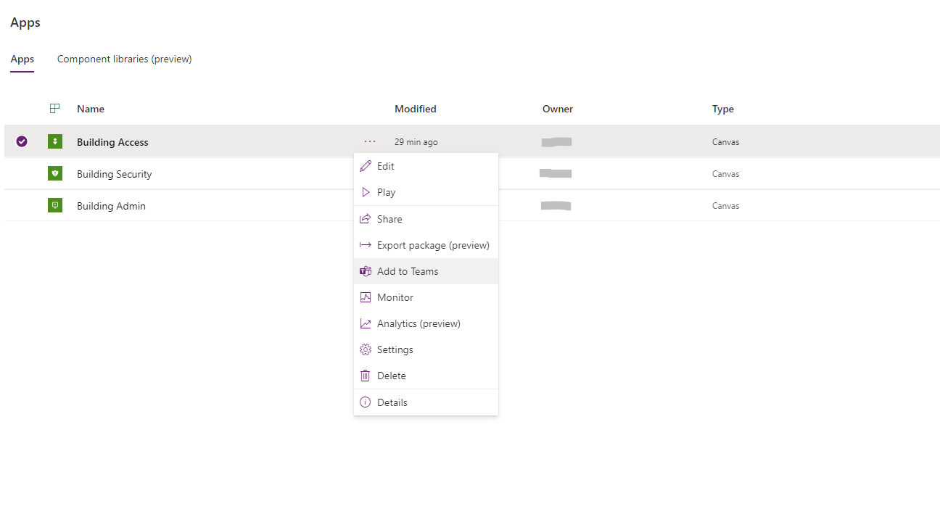

1. Click Download app.

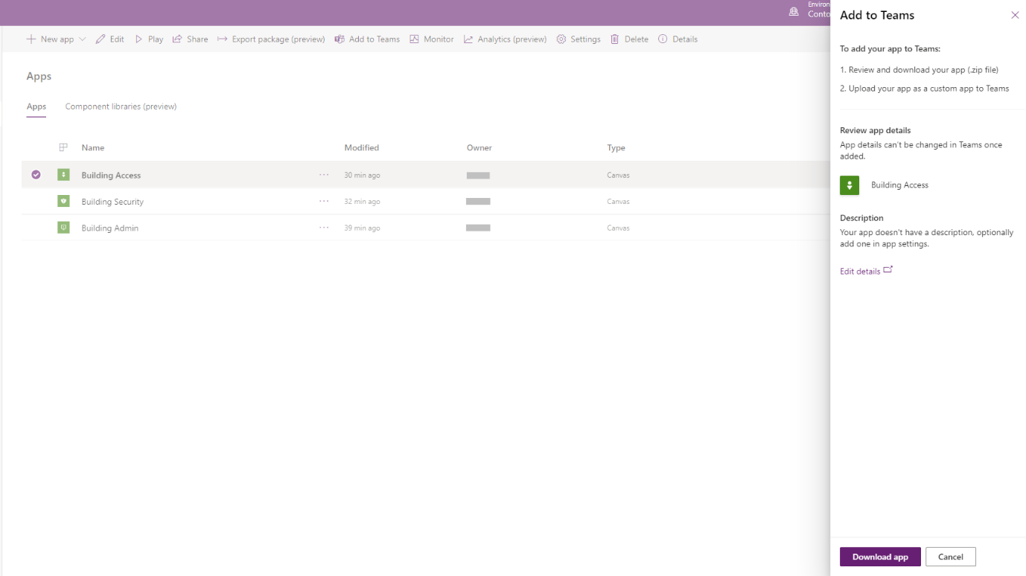

1. This will download a zip file which can be uploaded to Teams in the next step, so save the file to a location you can remember and easily access.

## Add app to your Teams app store

1. Once the app has been downloaded from your Power Apps homepage as a zip file, open Teams and navigate to the app store.
2. Use the “Upload a custom app” function at the bottom-left. If you don’t see Upload a custom app option it may mean that this option is disabled for your organisation. Contact you team’s administrator and follow instructions in the “Notes” section below.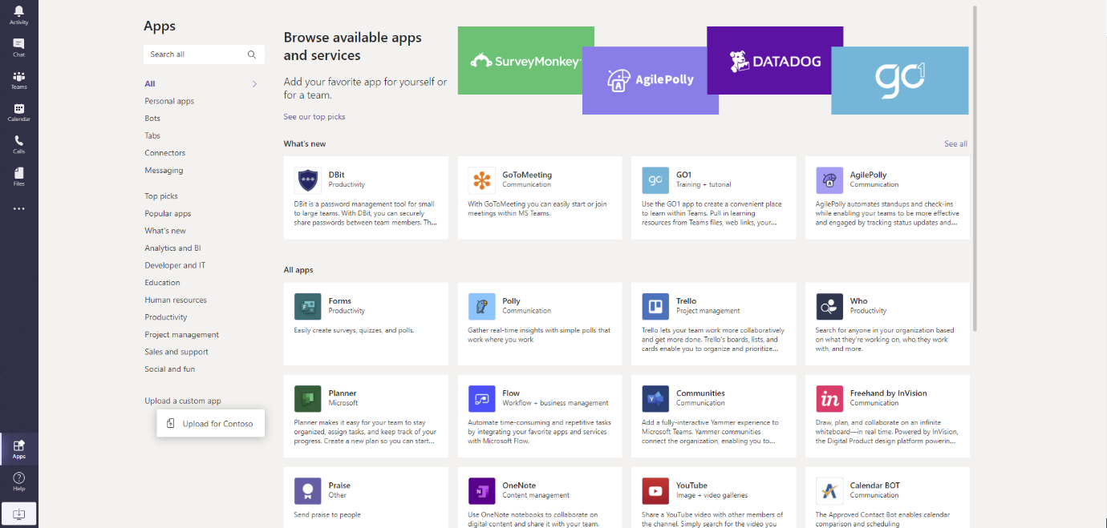
3. Click Upload for [Organisation Name].
4. Upload the zip file you downloaded from Power Apps in the prior step.

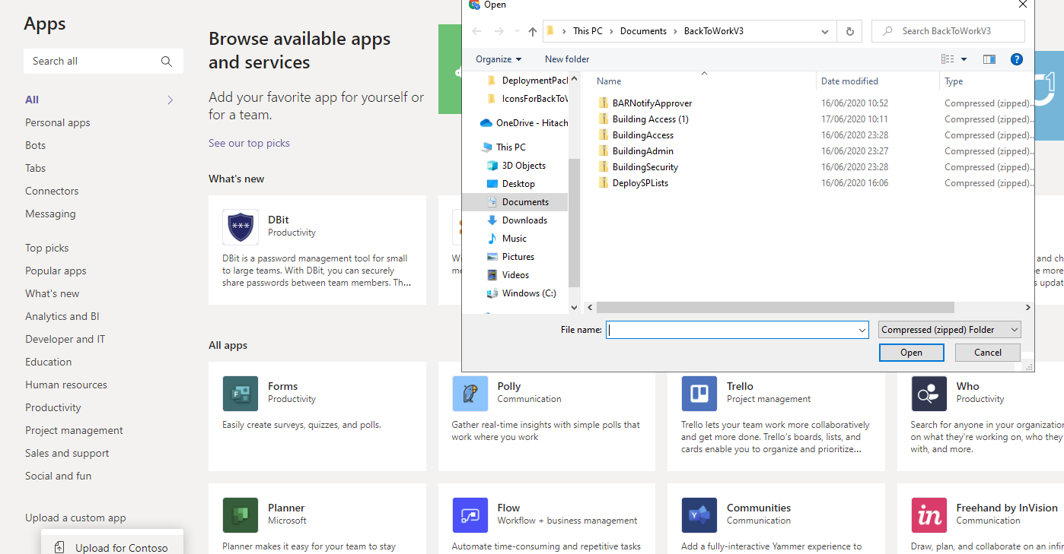

1. Once uploaded, the app appears in the app store.

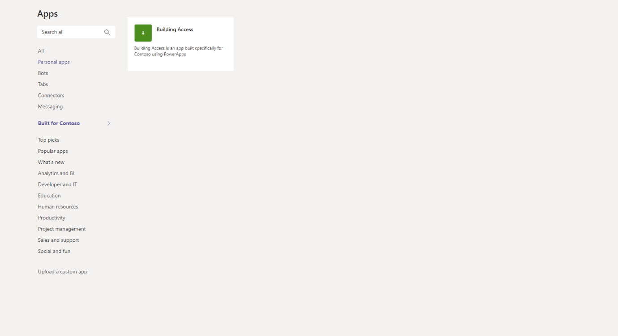

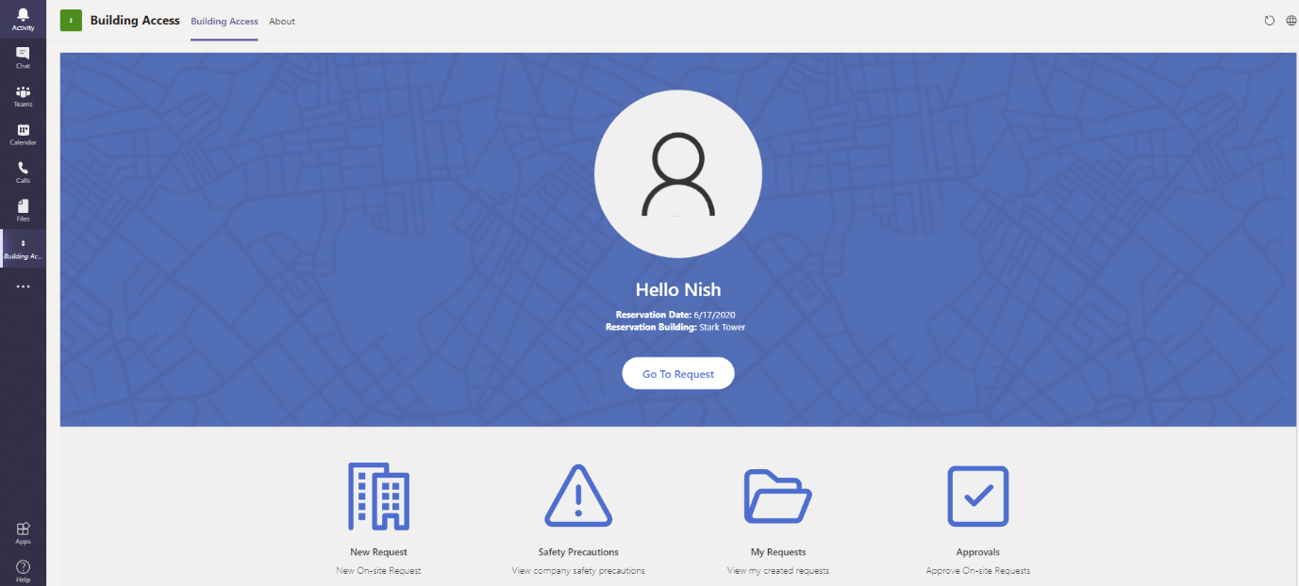

***Note***

* *In case you don’t see Upload Custom app option, it may mean this functionality is disabled for your organisation.*
* *This setting could be turned on by navigating to* [*teams admin centre*](https://admin.teams.microsoft.com/)*.*
* *Under Team’s apps, select Setup Policies.*
* *Switch on Upload custom apps setting.*

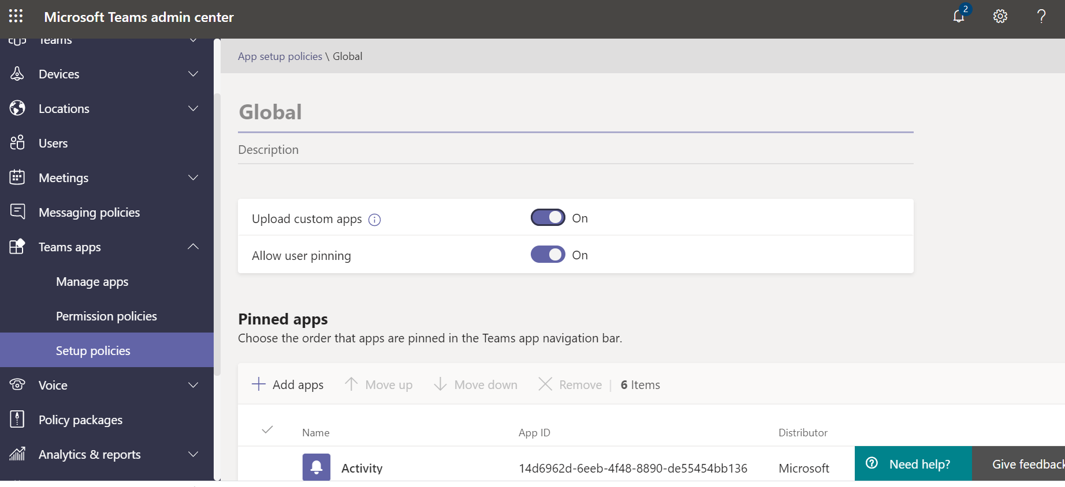

## Pin the app to your organisation’s Teams app bar (Teams Admins)

Teams Admins have a great opportunity to drive awareness and highlight the apps that their organization should be using. As with any app, Teams Admins can use the [Teams Admin Center](https://admin.teams.microsoft.com/) to pin this app to the Teams App bar for their entire tenant.

1. Under “Teams apps”, select “Setup policies”, and choose which policy to update (the “Global” policy, for example).

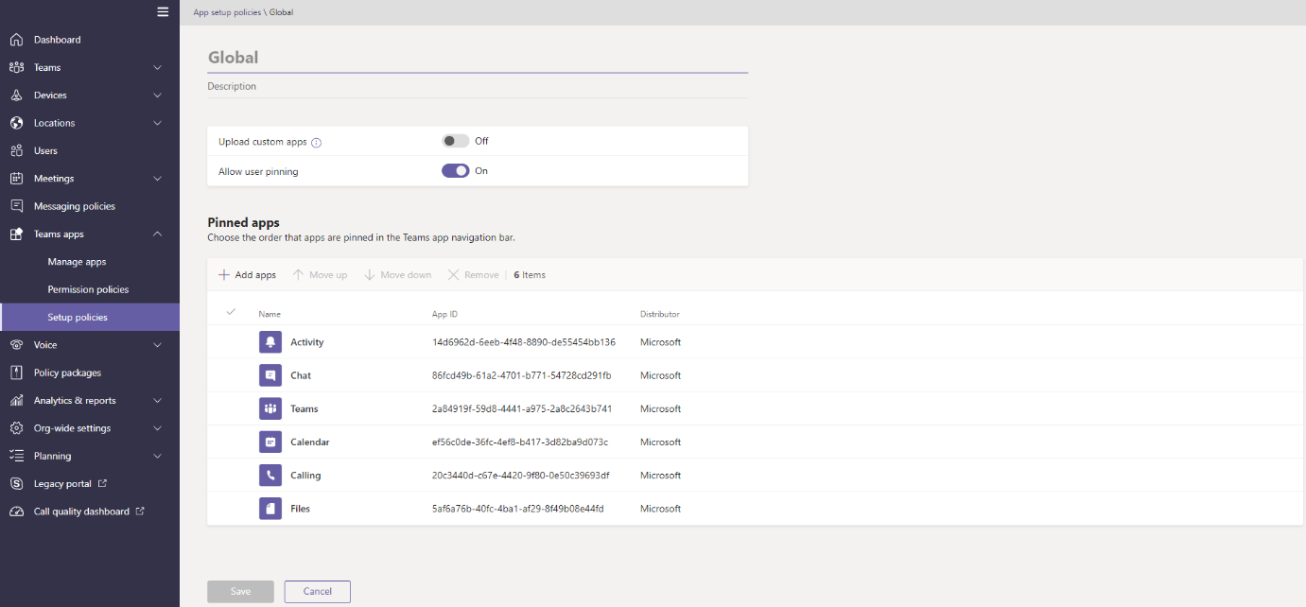

1. Now select “Add apps” under the “Pinned apps” section, and search for the app to pin (based on the name you gave the app in Power Apps).
2. Click Add to select the app to pin.

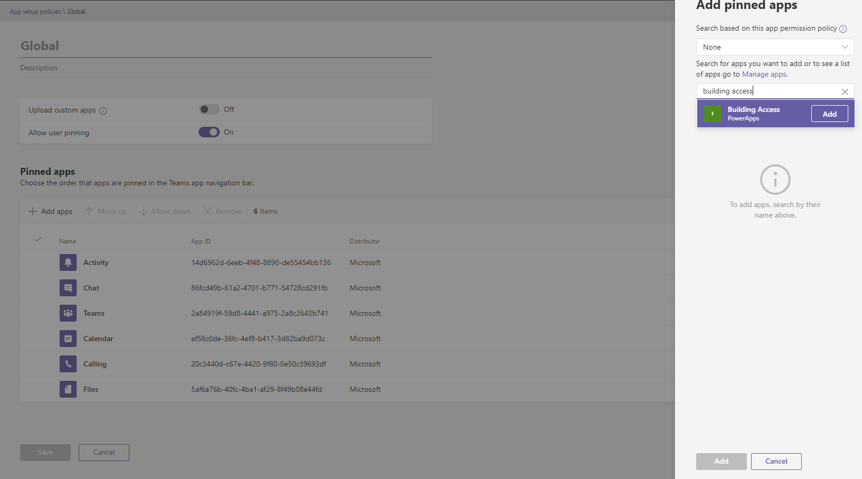

1. Shortly, all users in this policy will see this app appear on their Teams app bar.

## Pin the app to your personal Teams app bar (any Teams user)

Even if your Teams Admin has not taken steps to add this app to the Teams app bar for your tenant, any user can add this app their personal app bar.

1. Click the app from the app store.

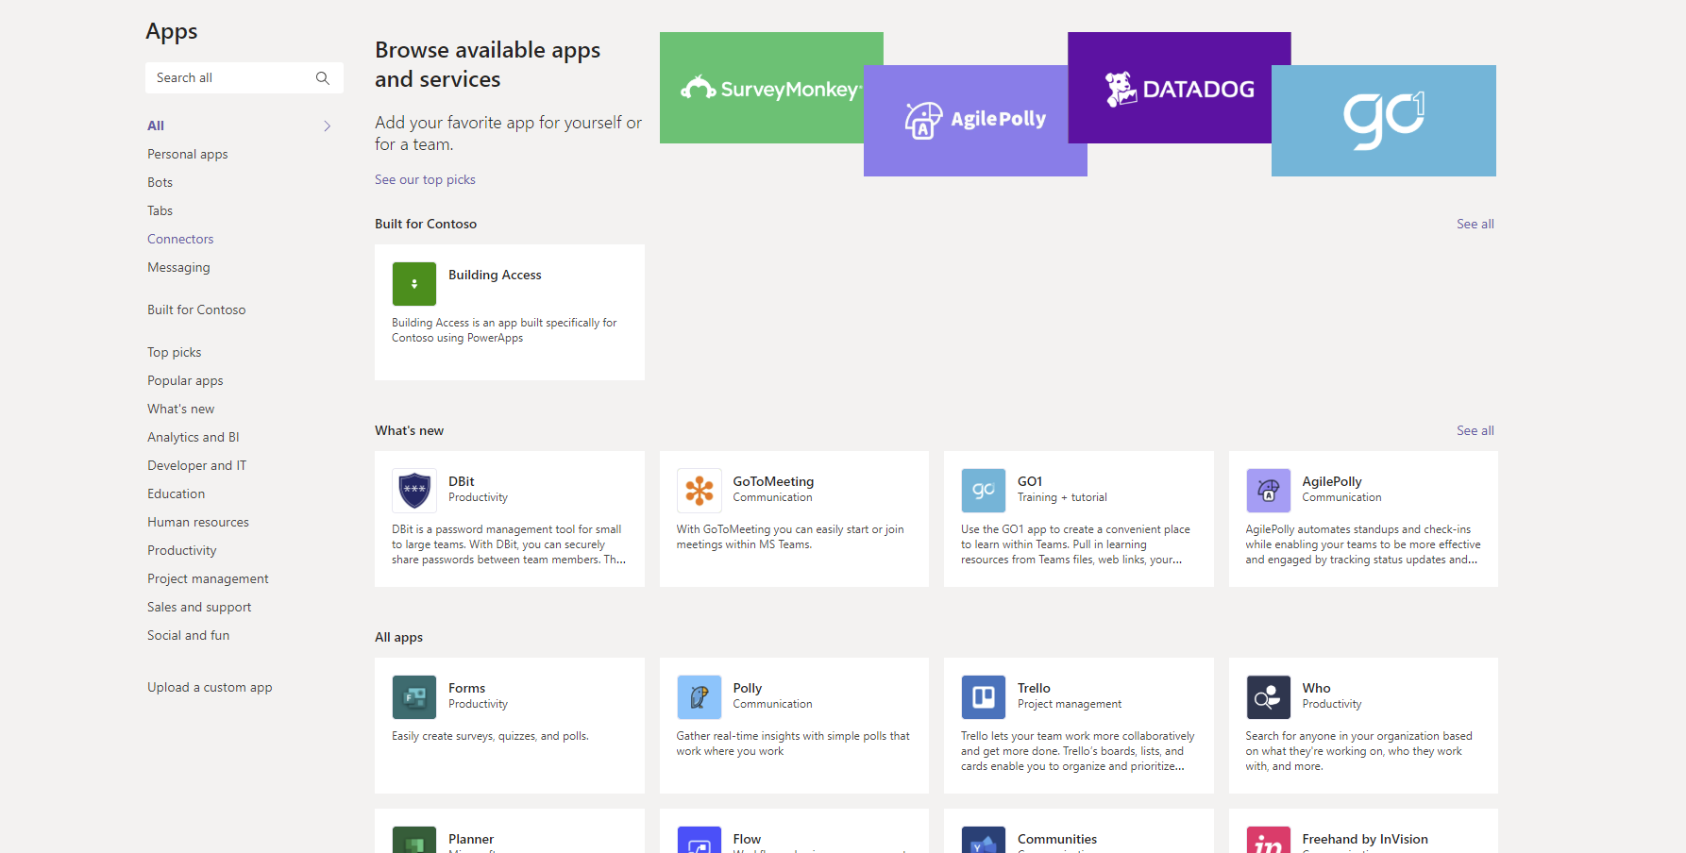

2. Click Add to add app to your app bar.

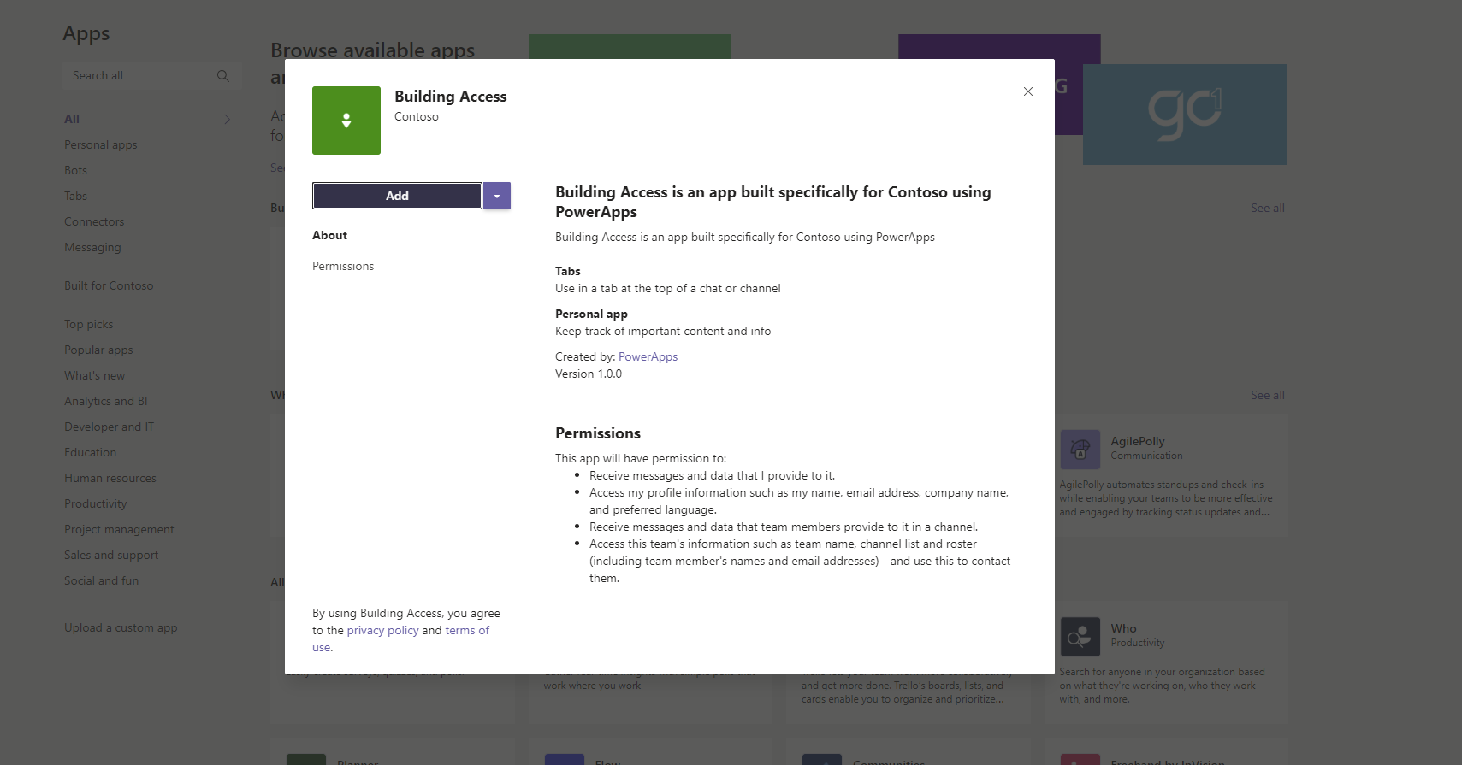

1. Once the app icon appears on your app bar, right click the icon and select “pin”. The app icon will remain on your app bar to provide you easy access, even after you navigate away from the app.

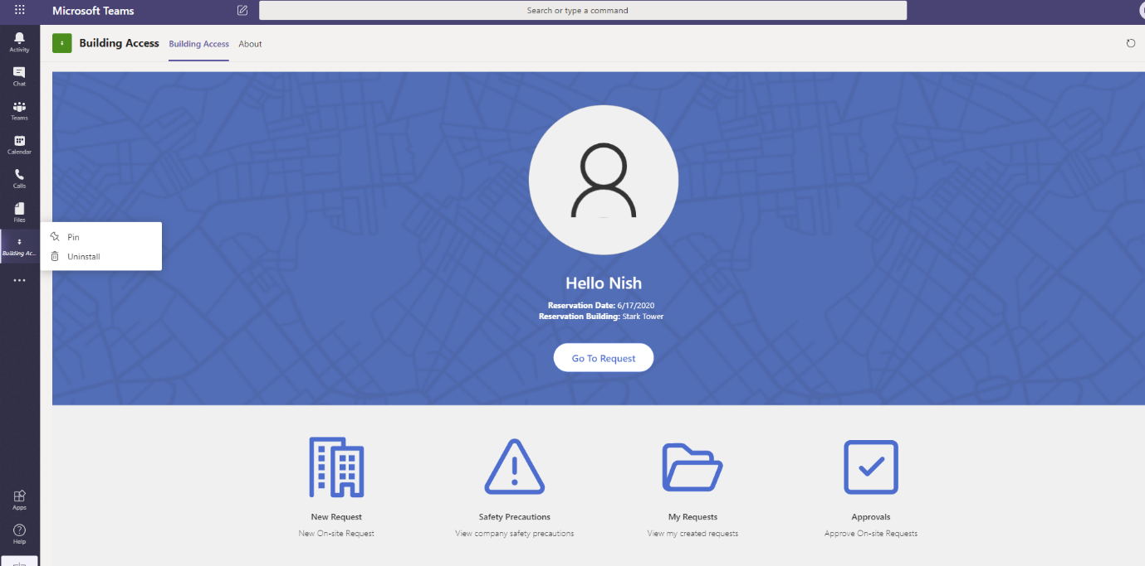

# Adding Building Admin app as a tab

The Building Admin app provides an easy way for admins to manage key settings and reference data for the Building Access app. Adding the Building Admin App as a tab to an admin team is a great way to ensure ease of access. To add the Admin app to a tab, follow the following instructions.

1. Navigate to your Admin team and select a channel.

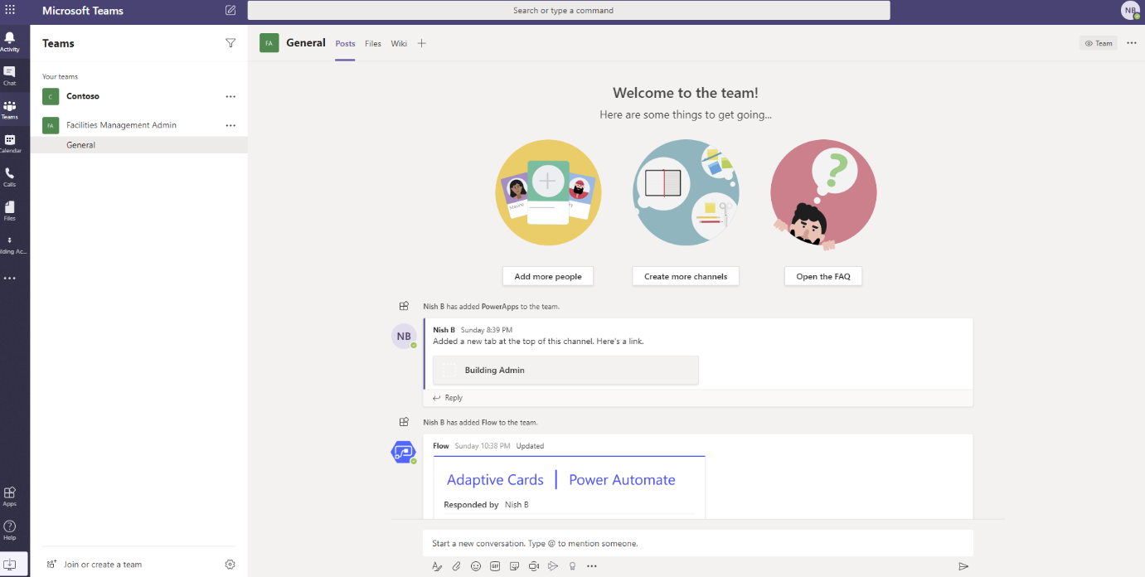

1. Click the + icon on the tabs bar.
2. Search for PowerApps in the Add a tab dialog and select PowerApps.

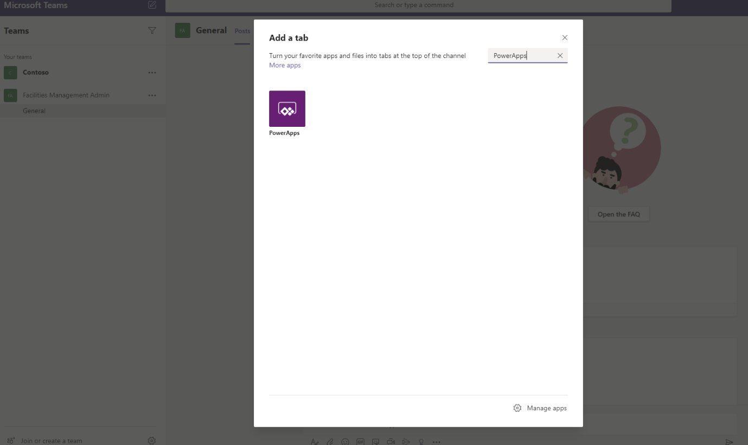

1. Next dialog presents all the PowerApps shared with the you.
2. Select the Building Admin App and click Save

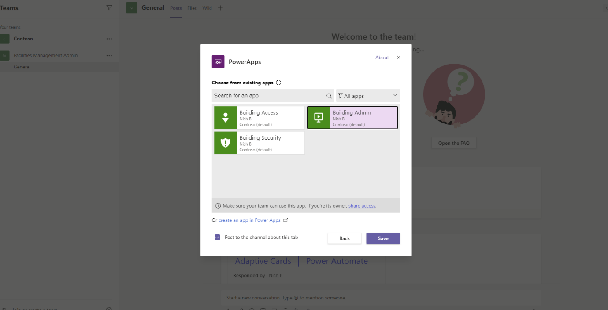

1. The app is added as a tab.

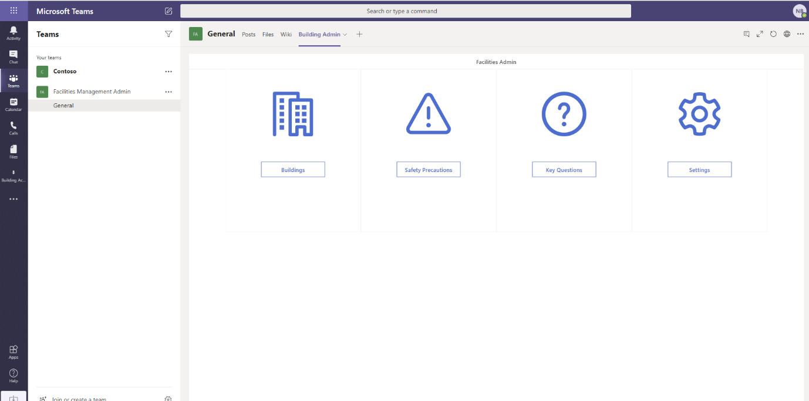

# Configuring PowerBI report

Once you have configured all the apps, users will start requesting access to the buildings. Managers or admins will approve them and security personnel will be able to check in and check out users. PowerBI report provides an excellent way to report on the data captured and extract some key information.

Follow the steps below to configure the PowerBI report.

1. Download Building Access Insights.pbix from the GitHub repository.
2. Open the pbix file using PowerBI desktop.
3. Click on Tranform data under Home menu.

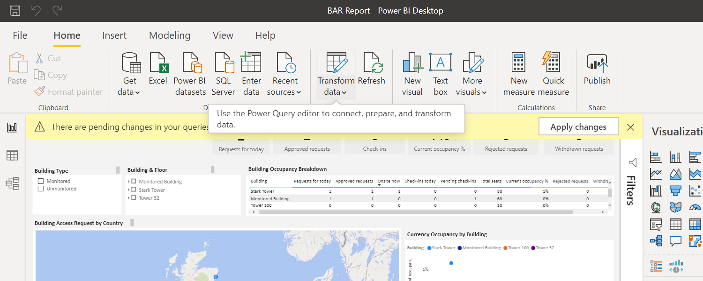

1. In the transform data dialog, under parameters change the values for SharePoint URL parameter to the URL of you SharePoint site.

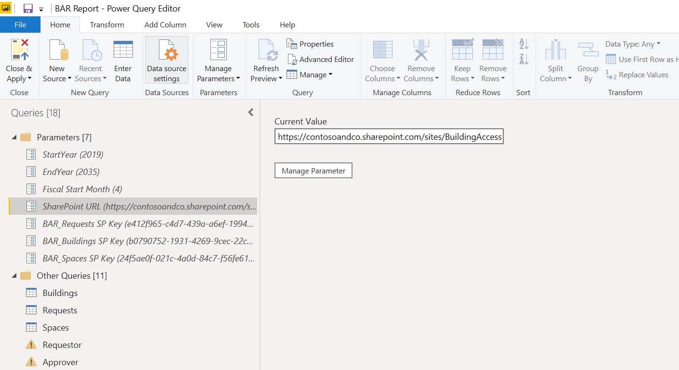

1. Under parameters change the values for BAR_Requests SP Key to GUID of the BAR_Requests list.

Note:

* To extract GUID of the list, navigate to SharePoint list.
* Navigate to List Settings under settings icon.
* Make note of the List GUID from the URL



1. Under parameters change the values for BAR_Buildings SP Key to GUID of the BAR_Buildings list.
2. Under parameters change the values for BAR_Spaces SP Key to GUID of the BAR_Spaces list.
3. Click on Data Source Settings.

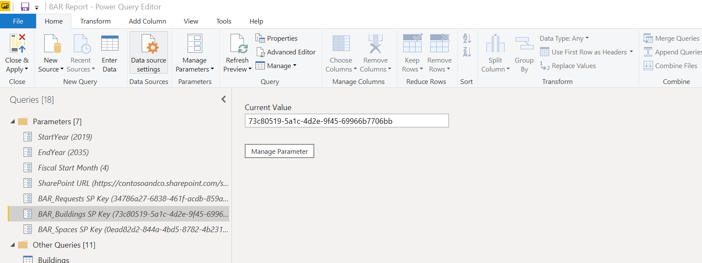

1. In the Data Source settings dialog, click Edit permissions.

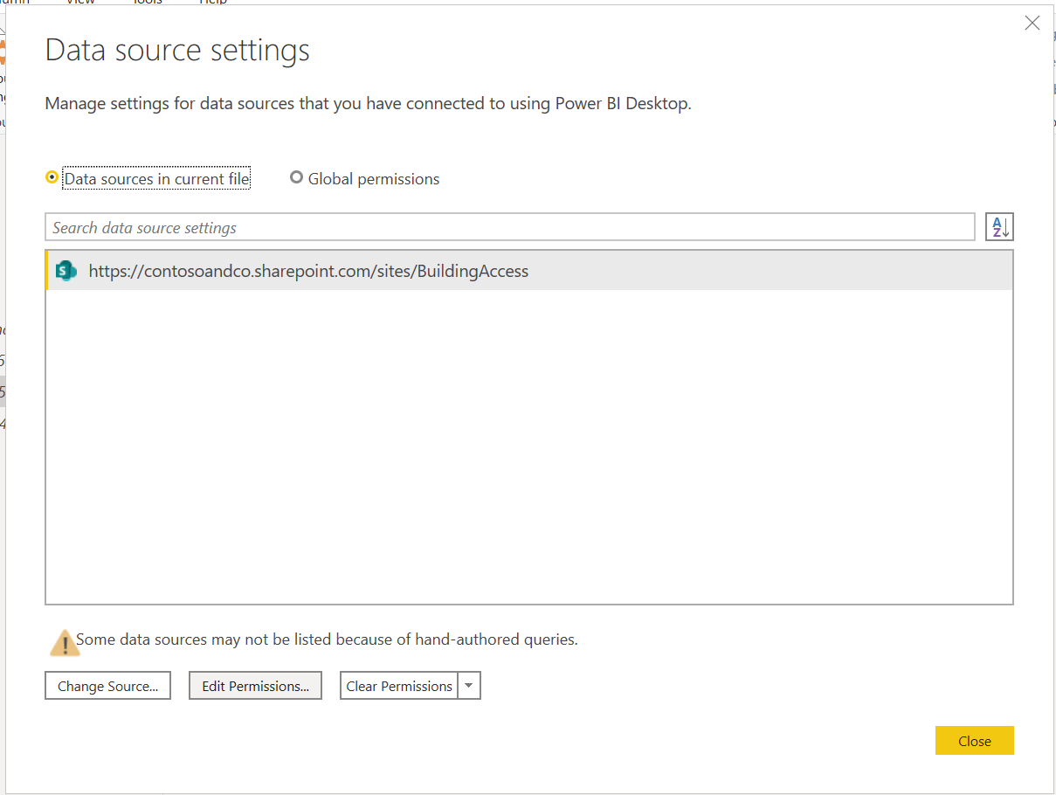

1. In the Edit Permissions Dialog, Click Edit and leave everything else as default.
2. Select Microsoft account and select Sign in as different user.

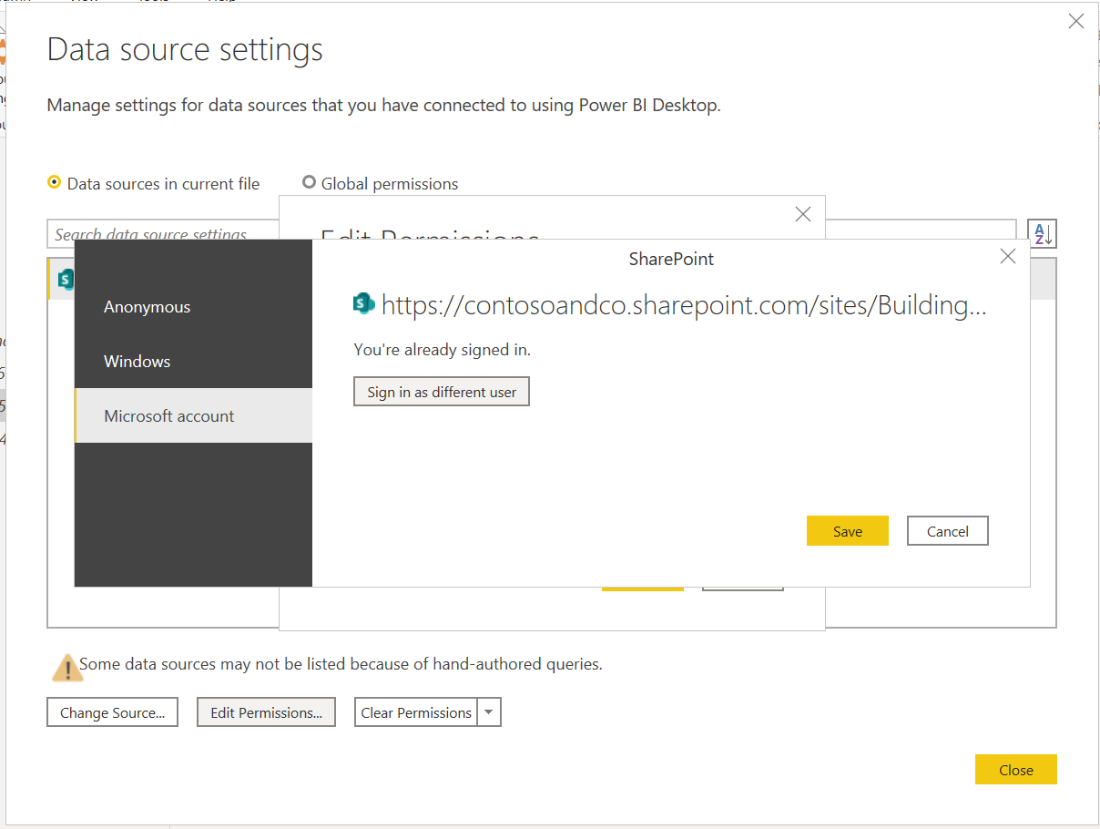

1. Sign in using credentials for a user account that has at least read access to all lists in the SharePoint site.
2. Once you are signed in, a message appears “You are currently signed in”, Click Save.

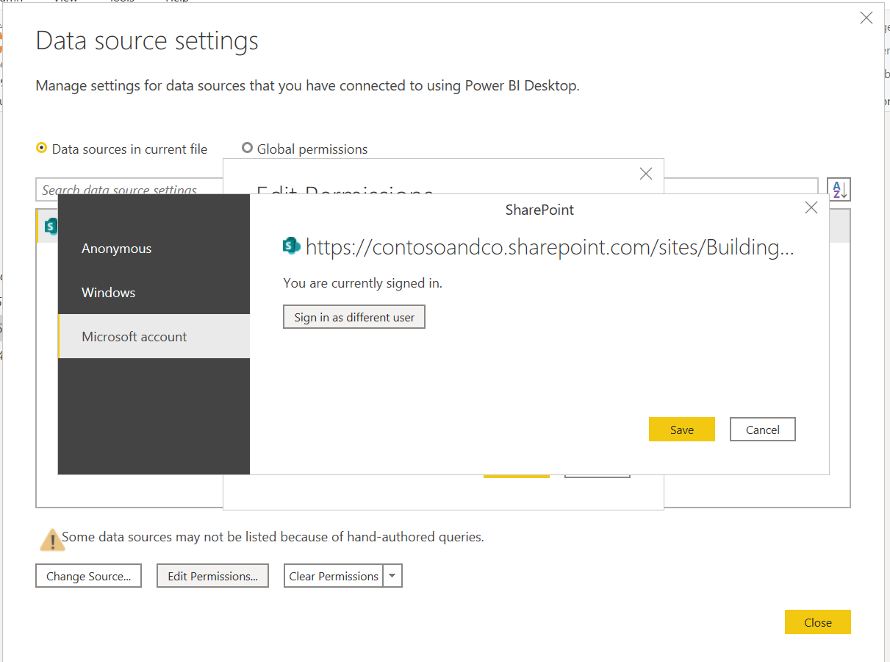

1. Click ok on Edit permissions dialog.

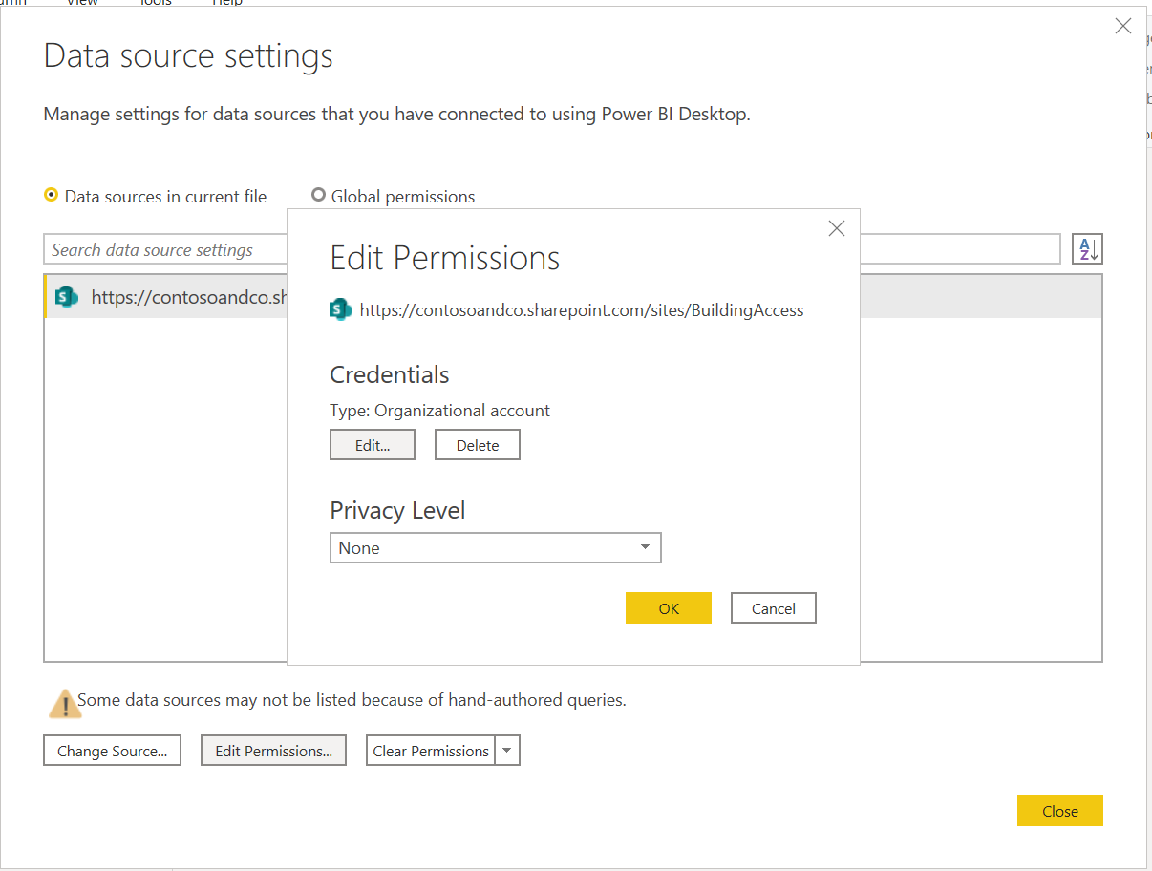

1. Click Close in the Data Source settings dialog.
2. Verify by clicking on the Queries, which should now show data.

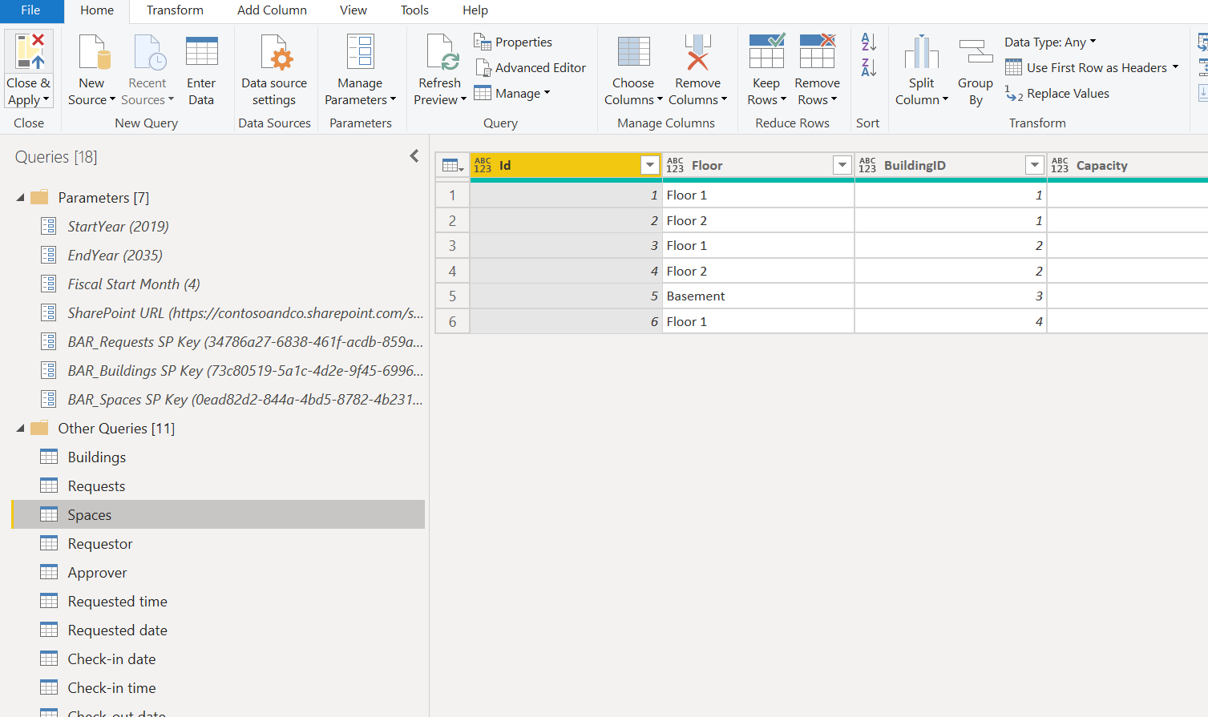

1. Click Close & Apply.
2. The PowerBI report should update with new data.